**MS-DOS**

Short for **Microsoft Disk Operating System**, **MS-DOS** is a non-graphical command line operating system created for IBM compatible computers. MS-DOS was first introduced by Microsoft in August 1981 and was last updated in 1994 with **MS-DOS** 6.22. Although the MS-DOS operating system is rarely used today, the command shell commonly known as the **Windows command line** is still widely used.

The DOS operating system programs are stored on some secondary storage device. It is then loaded into **RAM** when required. The DOS software is divided into three parts stored in three different files on a disk. This disk which contains these three files is called a Bootable disk. The three files loaded on this disk are **IO.SYS**, **MSDOS.SYS** and **COMMAND.COM**.

* **IO.SYS** file contains the device drivers for the standard devices such as keyboard, disk, floppy, printer and monitor are present. The IO.SYS also contains SYS.INI file which loads MSDOS.SYS from hard disk into memory. The IO.SYS is also called IBMBIO.COM.
* **MSDOS.SYS** file is also called DOS Kernel. It contains all the modules for process management. These modules are written in machine independent manner so that they could be easily ported. The MSDOS.SYS is also called IBMDOS.SYS in some systems. The **DOS kernel** performs four basic important  functions:-
  + **Memory Management-** It allocates memory to different application programs on demand.
  + **Process Management-** It does the management of the program by loading the program requested by the user from disk in memory and helps in execution of the program. It also helps to recover system files when unwanted termination occurs.
  + **File Management-** It does the management of files by reading, writing, displaying renaming, copying and removing the files.
  + **Provides an Interface-** It establishes interface between the user and the hardware. It works as an intelligent agent by allotting various hardware device to various programs when needed.
* **COMMAND.COM**- The MS-DOS shell is known as COMMAND.COM. MS-DOS has about 70 or more commands that are partitioned into two categories- **Internal** & **External.**

**Features of MS-DOS**

It is a single user operating system and is a **CUI** (**C**ommand **U**ser **I**nterface). It interprets commands typed into the DOS mode.

* Standardization and openness of **MS-DOS** Architecture has greatly benefited software and hardware developers.
* Very good File, Client and Print server options.
* Most recent development in DOS i.e. **MS-DOS 7.0** (incorporated in Windows 95) has provided **GUI** (graphic user interface)
* It has a **CHKDSK** utility that helps to Detect, Diagnose and repair disk errors.
* It has ability to bypass some Startup commands when the user switches on the computer.
* The **VSAFE.COM** command helps to detect and remove viruses present in the user’s system.

**Types of DOS Commands**

The command generally means an instruction written in computer language that user types to execute a specific operation on the DOS prompt. The specific operations on the DOS prompt. The command interpreter accepts our input in a specific form. This specification is known as the **syntax** and the output is known as DOS **command**.

There are two types of Commands:

1. **Internal Commands**
2. **External Commands**

**Internal Commands**

Internal commands are those commands that are loaded automatically in the memory when **DOS** is loaded into memory during booting process. These commands are easier to learn and use and require no eternal files for their storage as in case of external commands. These commands are always available at the console of the user and are executed much faster than external commands. The internal commands are used for common jobs such as copying, erasing and renaming files. Some Common Internal Commands-

1. **CLS**

It is used to clear all the information from the display screen, bearing only the system prompt and a cursor on the upper left corner of the screen. It will display operating system prompt, if any, on the first line of the display.

**Syntax:**

**C:\>CLS**

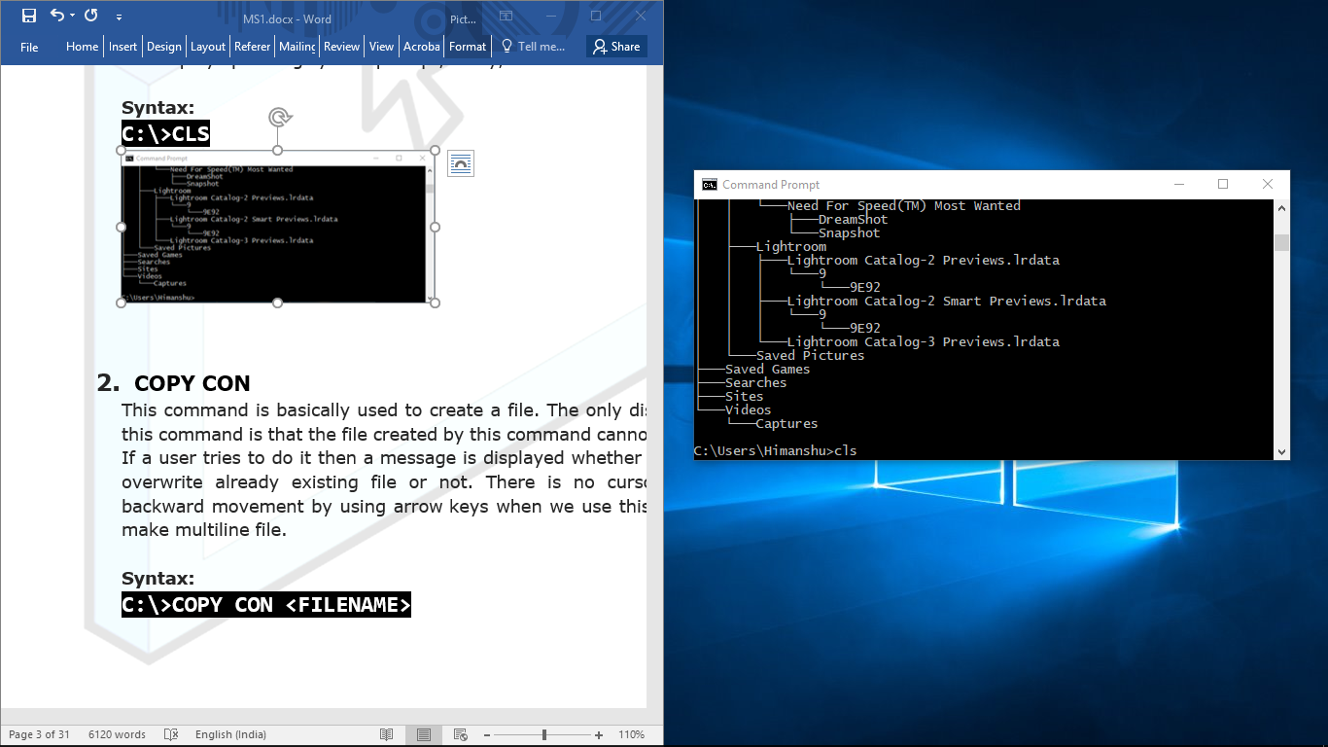 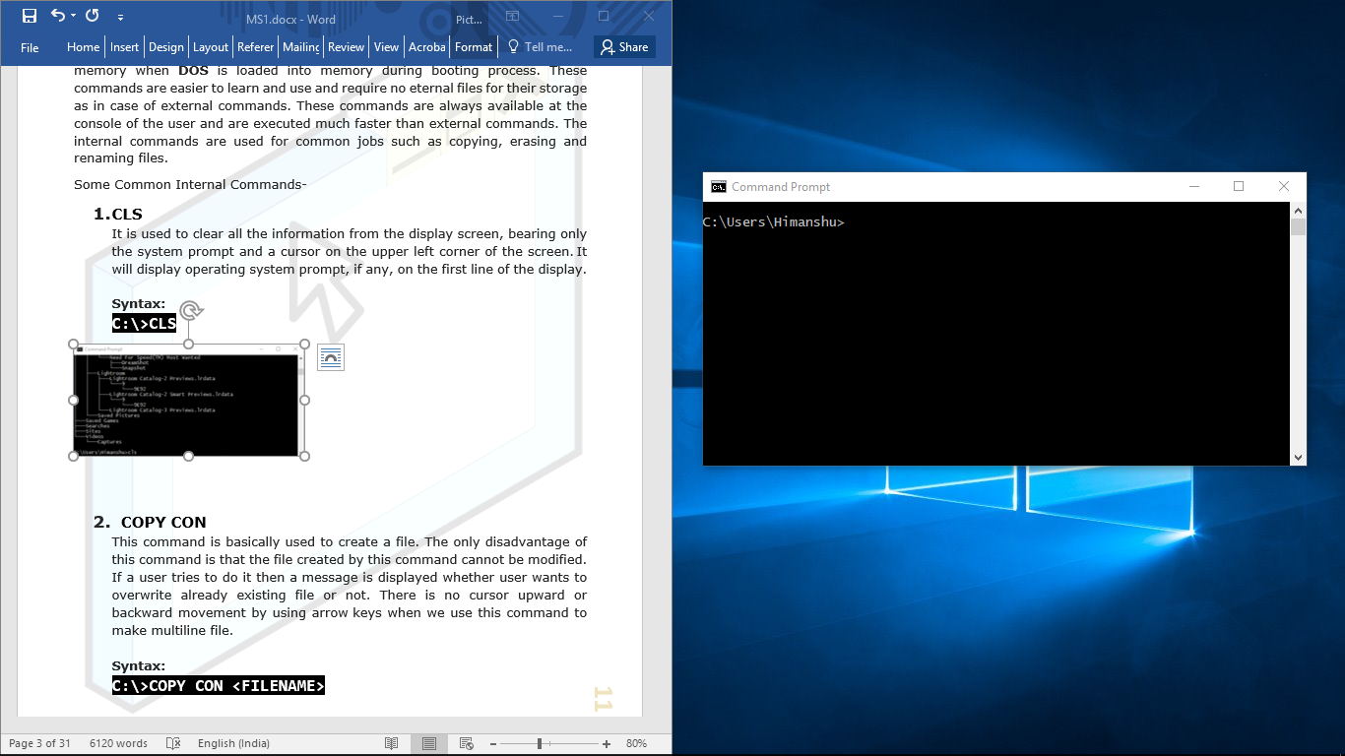

1. **COPY CON**

This command is basically used to create a file. The only disadvantage of this command is that the file created by this command cannot be modified. If a user tries to do it then a message is displayed whether user wants to overwrite already existing file or not. There is no cursor upward or backward movement by using arrow keys when we use this command to make multiline file.

**Syntax:**

**C:\>COPY CON <FILENAME>**

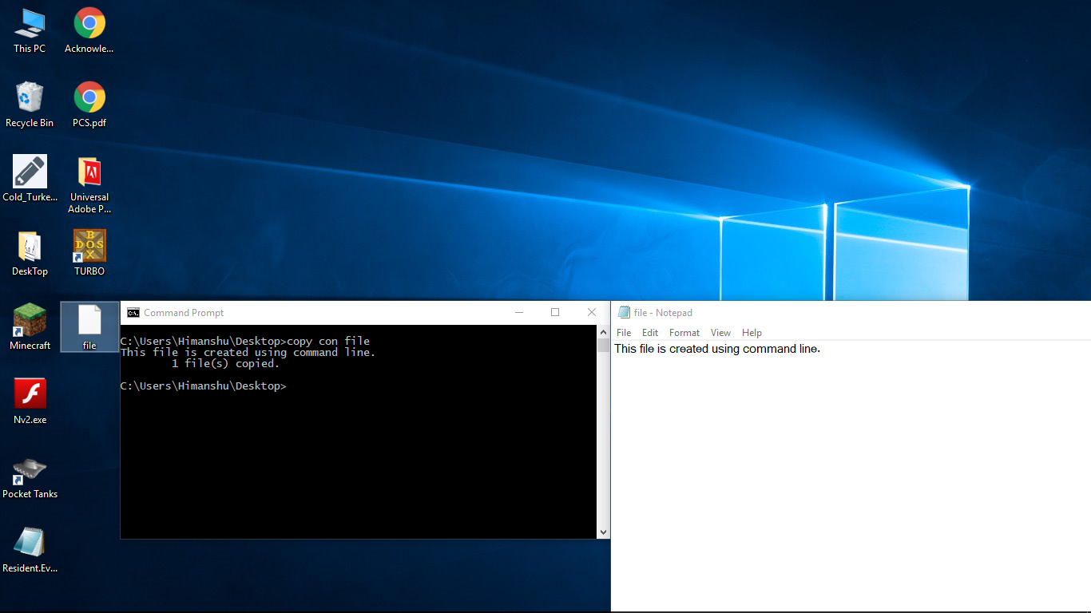

1. **CD** or **CHDIR**

Change current directory. Displays the current working directory when used without a path parameter.

**Syntax:**

**C:\>CD <DIRECTORY_NAME>**

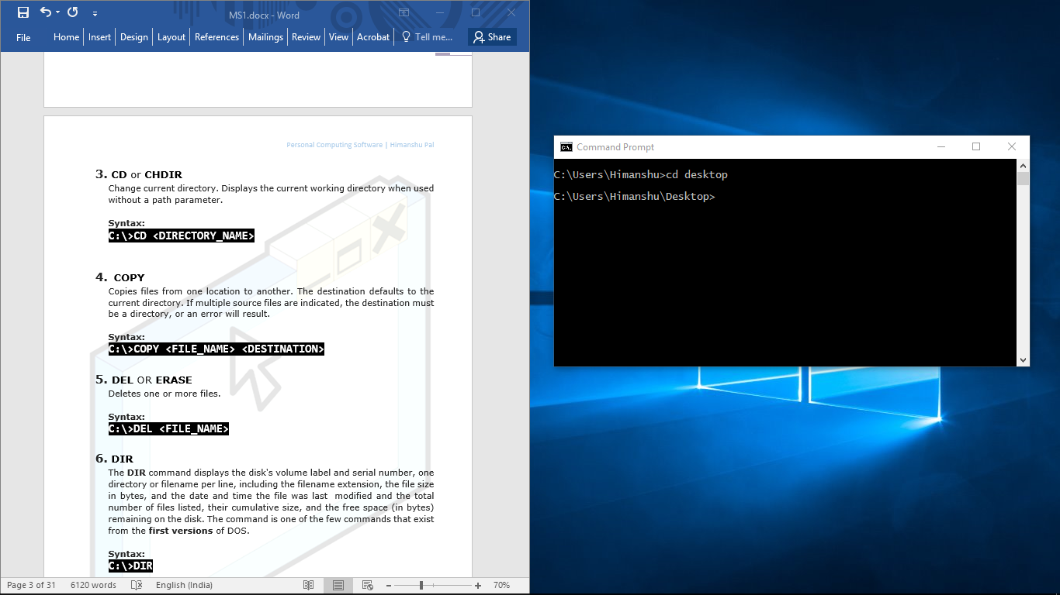

1. **COPY**

Copies files from one location to another. The destination defaults to the current directory. If multiple source files are indicated, the destination must be a directory, or an error will result.

**Syntax:**

**C:\>COPY <FILE_NAME> <DESTINATION>**

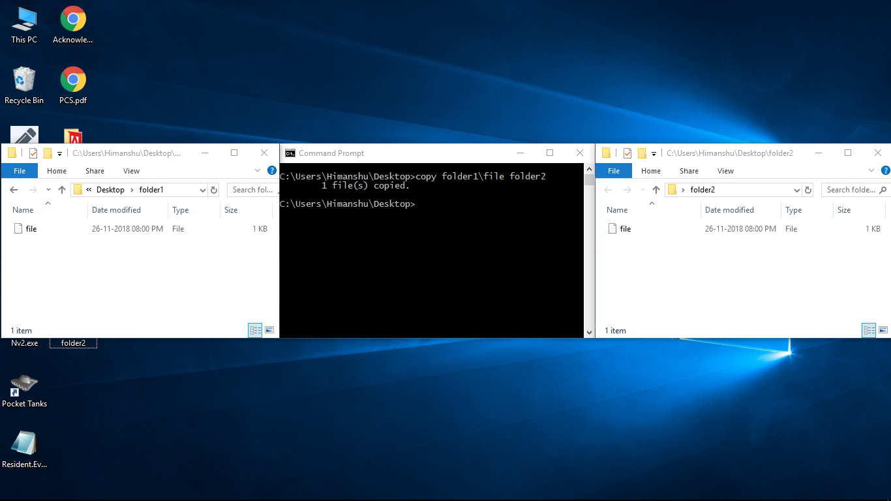

1. **DEL** OR **ERASE**

Deletes one or more files.

**Syntax:**

**C:\>DEL <FILE_NAME>**

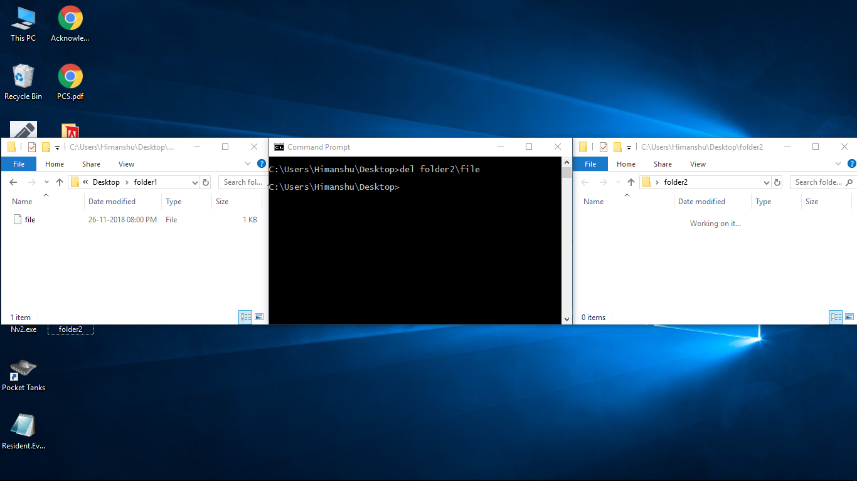

1. **DIR**

The **DIR** command displays the disk's volume label and serial number, one directory or filename per line, including the filename extension, the file size in bytes, and the date and time the file was last  modified and the total number of files listed, their cumulative size, and the free space (in bytes) remaining on the disk. The command is one of the few commands that exist from the **first versions** of DOS.

**Syntax:**

**C:\>DIR**

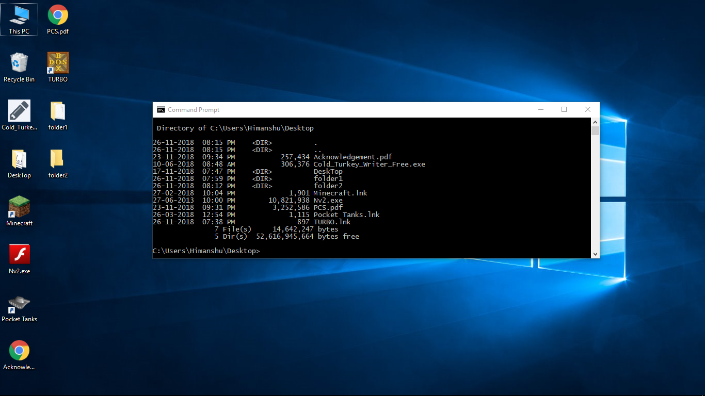

1. **MD** OR **MKDIR**

Makes a New Directory. The parent of the directory specified will be created if it does not already exist.

**Syntax:**

**C:\>MD <DIRECTORY_NAME>**

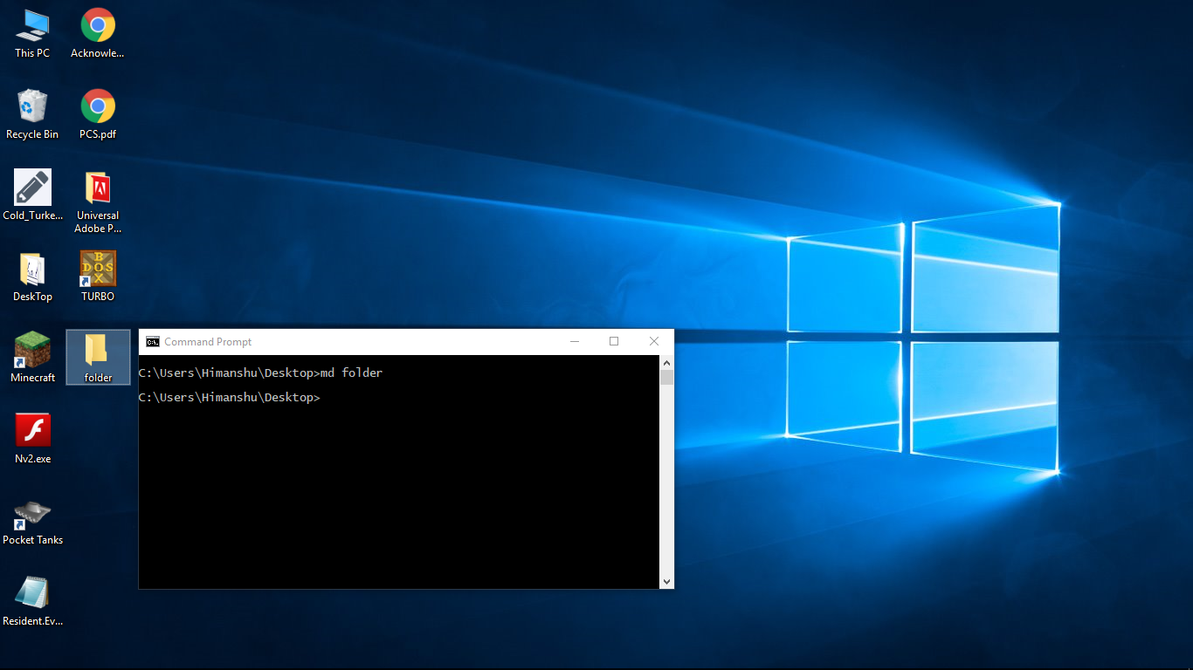

1. **RD** OR **RMDIR**

Remove a directory, which by default must be empty of files for the command to succeed (the **/S** flag removes this restriction)

**Syntax:**

**C:\>RD <DIRECTORY_NAME>**

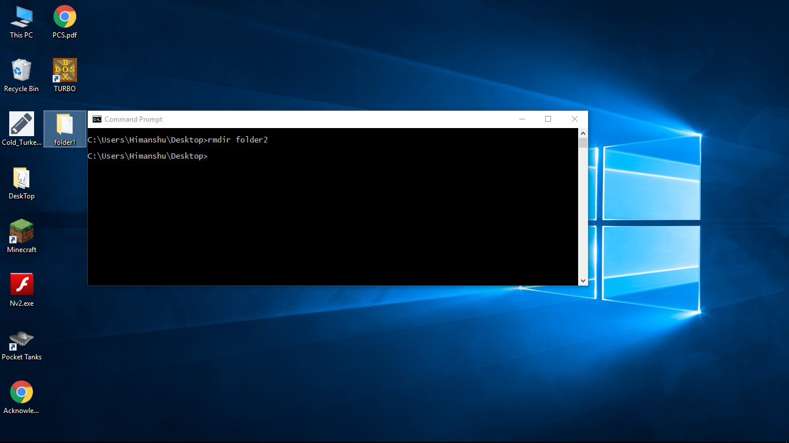

1. **REN**

Renames a file. Unlike the MOVE command, this command cannot be used to rename subdirectories, or rename files across drives.

**Syntax:**

**C:\>REN <FILE_NAME> <NEW_NAME>**

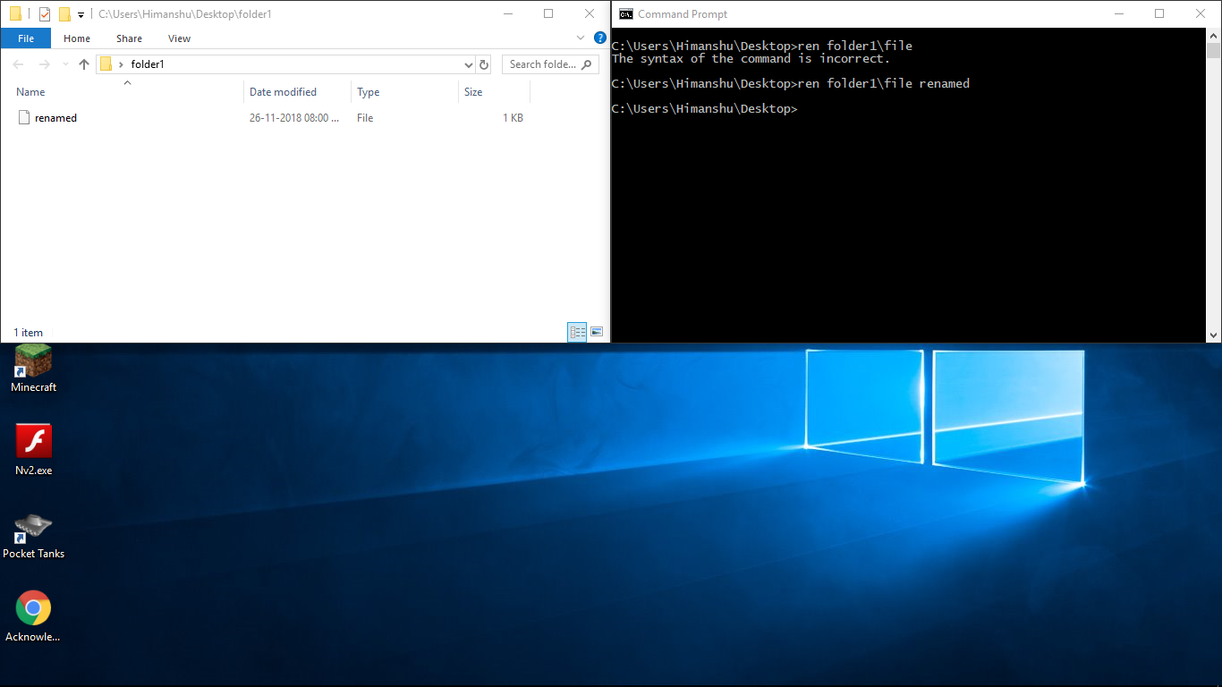

1. **TREE**

Shows the directory Tree of the current directory.

**Syntax:**

**C:\>TREE**

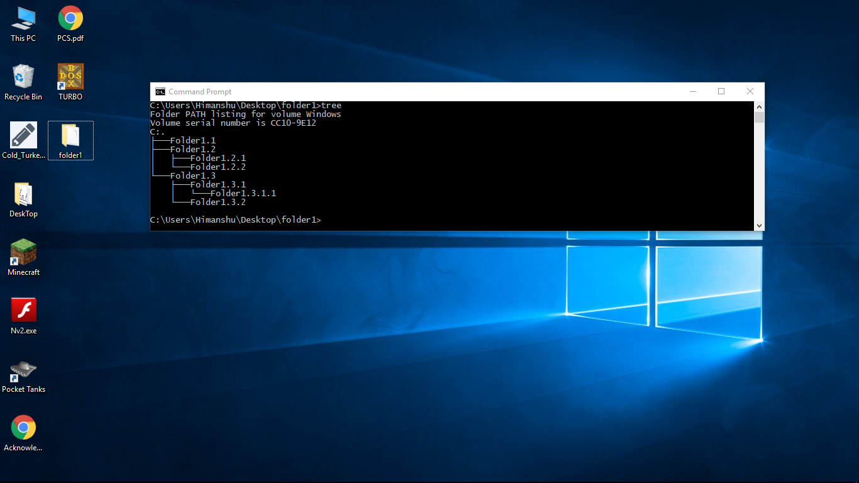

1. **VER**

Shows the version of **MS-DOS** you are using.

**Syntax:**

**C:\>VER**

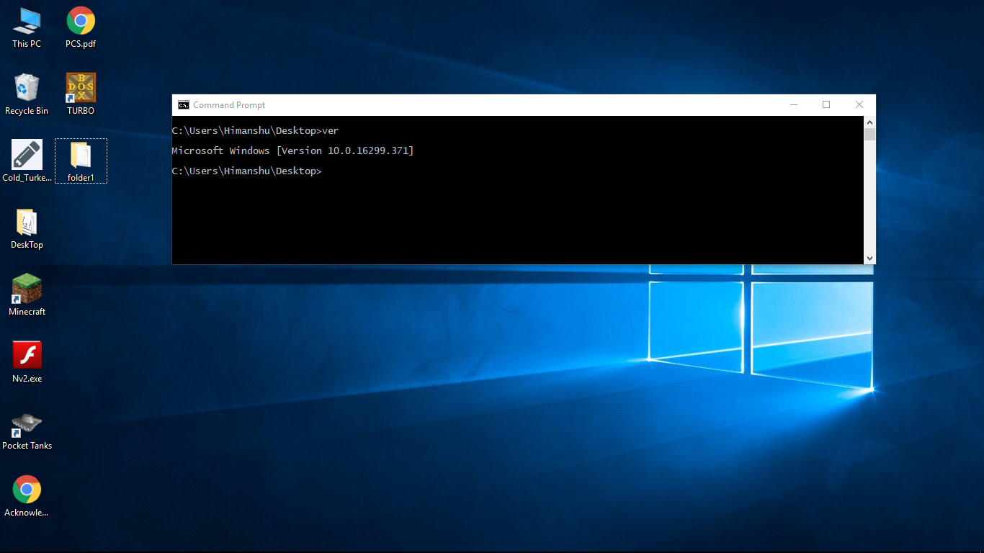

1. **TIME** and **DATE**

Display and set the Time and Date.

**Syntax:**

**C:\>TIME** and **C:\>DATE**

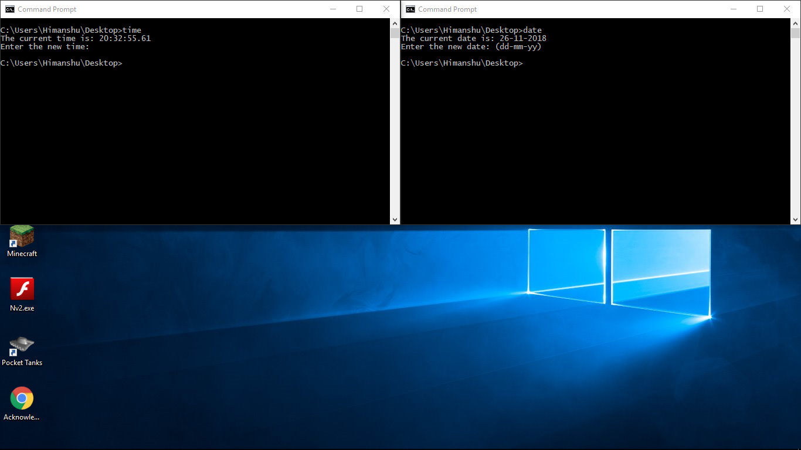

1. **EXIT**

Exits the current command processor. If the exit is used at the primary command, it has no effect unless in a DOS window under Microsoft   Windows, in which case the window is closed and the user returns to the Desktop.

**Syntax:**

**C:\>EXIT**

**External Commands**

The external commands are used less frequently and are stored in some external files which are in some secondary storage device. Whenever an external command is to be executed the external file in which that particular command is stored in transferred from the secondary storage i.e. disk to main memory i.e. RAM.

All executable files with extensions .COM, .EXE, and .BAT are the external commands. These commands are used for relatively jobs like comparing two files, formatting disk etc. For using external commands we need to use corresponding command file available in DOS.

Types of External Commands-

1. **ATTRIB**

Change or view the attributes of one or more files. It defaults to displaying the attributes of all files in the current directory.

**Syntax:**

**C:\>ATTRIB [-ARGS] <FILE_NAME>**

**Options:**

To add an attribute attach a '+' in front of it.

To remove an attribute attach a '-' in front of it.

Attributes include-

* **-R** -> Read-only
* **-A** –> Archive
* **-S** –> System
* **-H** -> Hidden

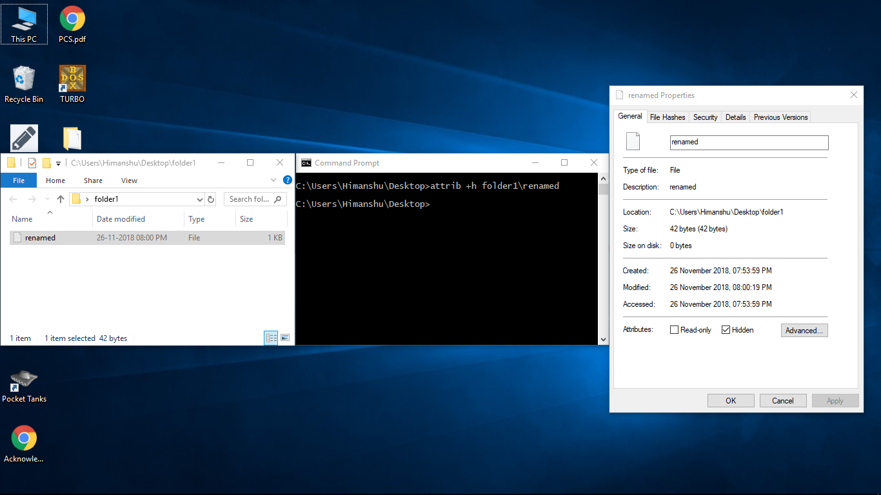

1. **CHKDSK**

Verifies a storage volume (Hard disk, Partition, Floppy disk, Flash drive, etc.) for file system integrity.

**Syntax:**

**C:\>CHKDSK *DRIVE_LETTER:* [PATH|FILE_NAME] [-OPTIONS]**

**Options:**

* **/F** -> Fixes errors on the volume (without /F , **CHKDSK** only detects errors)
* **/P** -> Forces a full verification.
* **/R** -> Searches for defective sectors and recovers legible information (applies /F)
* **/X** -> Unmounts the volume before processing if needed. (**Note:** An mounting temporarily invalidates all pointers/handlers to the volume until process is completed)

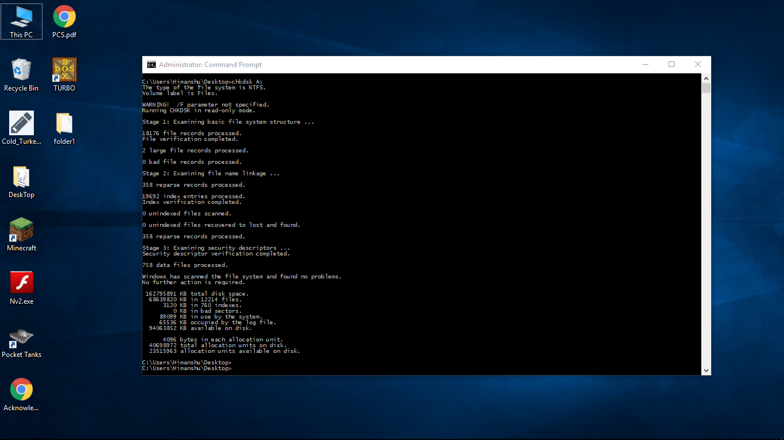

1. **DEFRAG**

Defragments a disk drive.

**Syntax:**

**C:\>DEFRAG *DRIVE_LETTER:* [-ARGS]**

**Options:**

* **-A** –> Analyses the fragmentation of a disk drive.
* **-F** –> Force defragmentation even if disk space is low.
* **-V** –> Verbose output mode.
* **-H** –> Defrag hidden files.

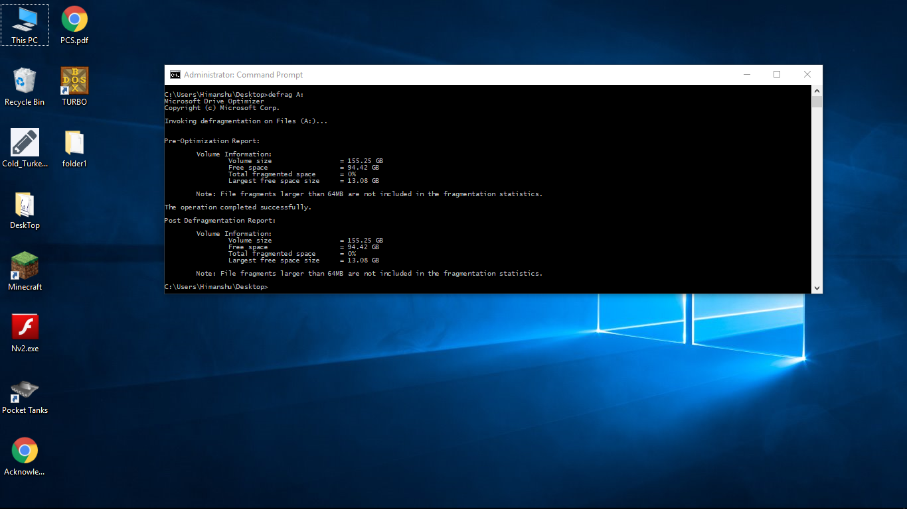

1. **FC** OR **COMP**

Compares two files or sets of files and displays the differences between them.

**Syntax:**

**C:\>FC[-OPTIONS] [PATH1|FILE_NAME1] [PATH2|FILE_NAME2]**

**Options:**

* **/A** -> Displays only first and last lines for each set of differences.
* **/B** -> Performs a Binary comparison.
* **/C** -> Disregards the case of letters.
* **/L** -> Compares files as ASCII text.
* **/LBN** -> Sets the maximum consecutive mismatches to the specified number of lines.
* **/N** -> Displays the line numbers on an ASCII comparison.
* **/T** -> Does not expand tabs to spaces.
* **/W** -> Compresses white space (tabs and spaces) for comparison.
* **/NNN** ->Specifies the number of consecutive lines that must match after a mismatch.

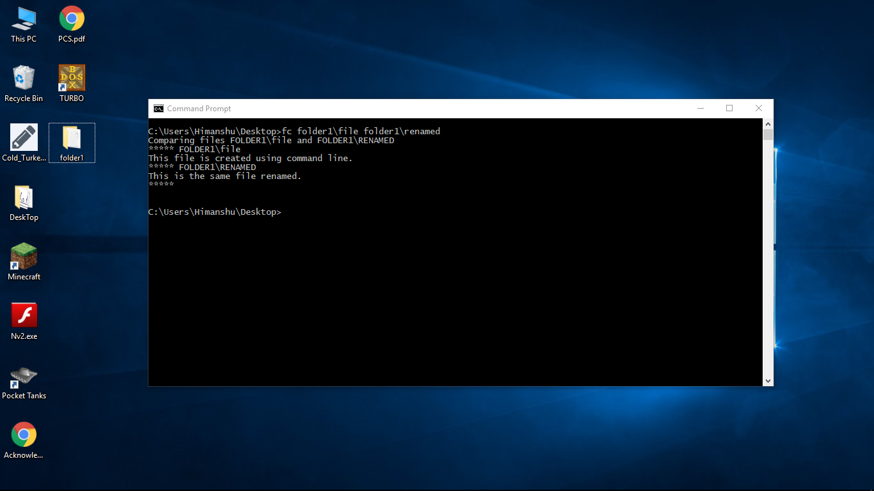

1. **FIND**

A Filter to find lines in the input data stream that contain or don't contain a specified string and send these to the output data stream.

Find may also be used as a pipe.

**Syntax:**

**C:\> FIND [-OPTIONS] “*KEYWORD”* [PATH | FILE_NAME]**

**Options:**

* **/V** -> Displays all lines NOT containing the specified string.
* **/C** -> Displays only the count of lines containing the string.
* **/N** -> Displays line numbers with the displayed lines.
* **/I** -> Ignores the case of characters when searching for the string.

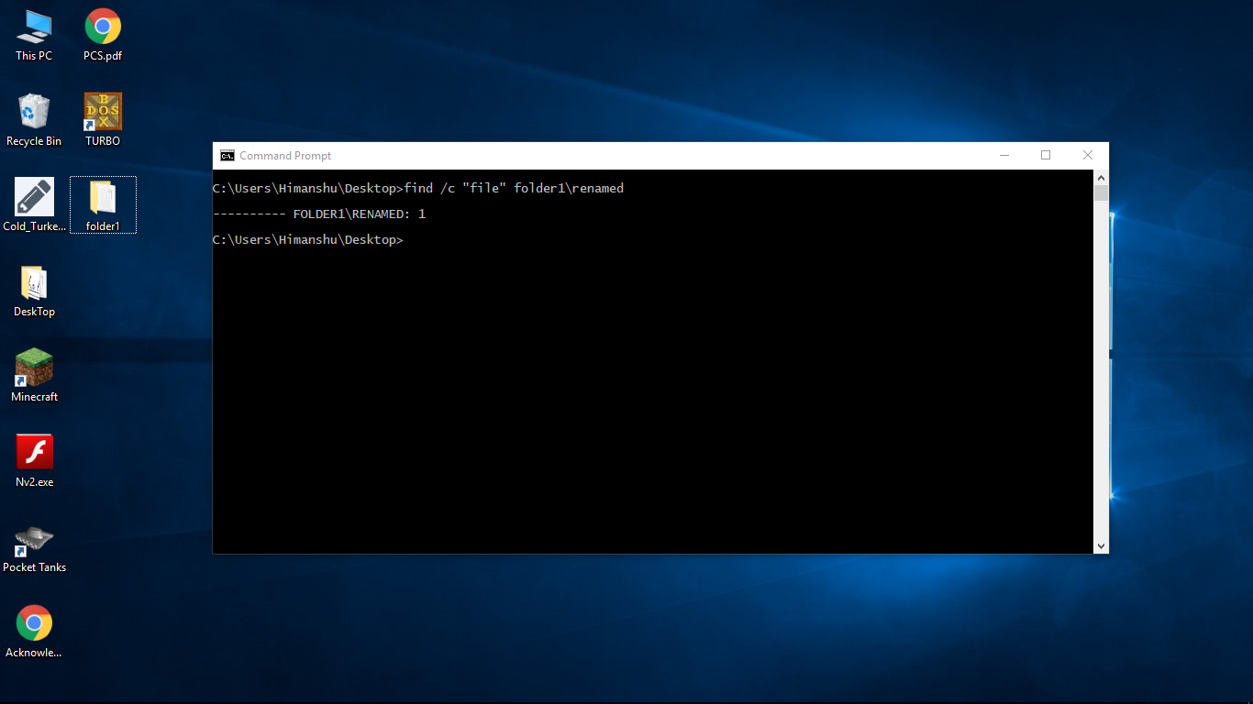

1. **FORMAT**

Delete all the files on the disk and Reformat it for MS-DOS. In most cases, this should only be used on Disk drives or other Removable media. This command can potentially erase everything on a computer's Hard disk.

**Syntax:**

**C:\>FORMAT *DRIVE_LETTER:* [-OPTIONS]**

**Options:**

* **/FS** -> Specifies the file system ([FAT](https://www.computerhope.com/jargon/f/fat.htm), [FAT32](https://www.computerhope.com/fat32.htm), [exFAT](https://www.computerhope.com/jargon/e/exfat.htm), [NTFS](https://www.computerhope.com/jargon/n/ntfs.htm), [UDF](https://www.computerhope.com/jargon/u/udf.htm))
* **/V** -> Specifies the volume label.
* **/Q** -> Performs a Quick Format.
* **/C** -> NTFS Only: Files created on the new volume will be compressed by default.
* **/X** -> Forces the volume to dismount first if necessary. All opened handles to the volume would no longer be valid.
* **/A** -> Overrides the default allocation unit size.

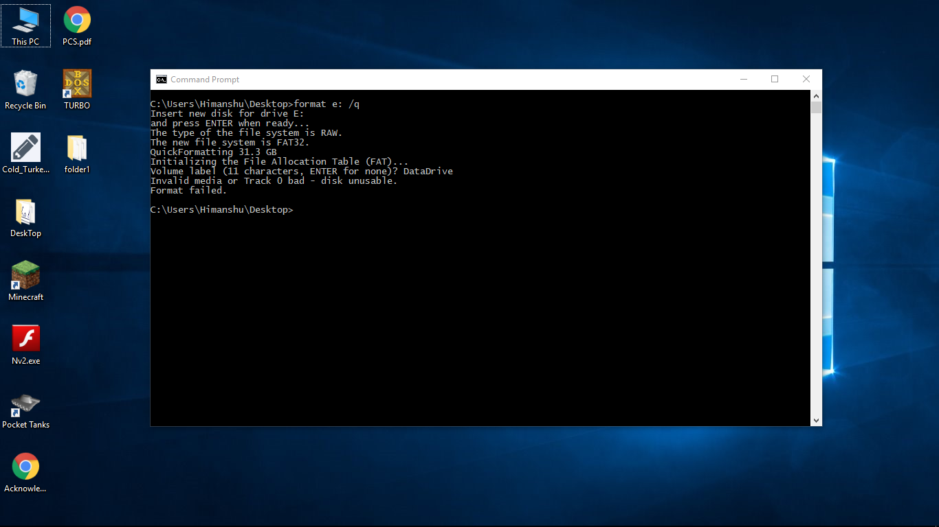

1. **HELP**

Help 'command' would give help on a specific command. By itself, it lists the contents of **DOSHELP.HLP**. Help for a specific command invokes the command with the **/?** Option.

**Syntax:**

**C:\>HELP *[*-*COMMAND]***

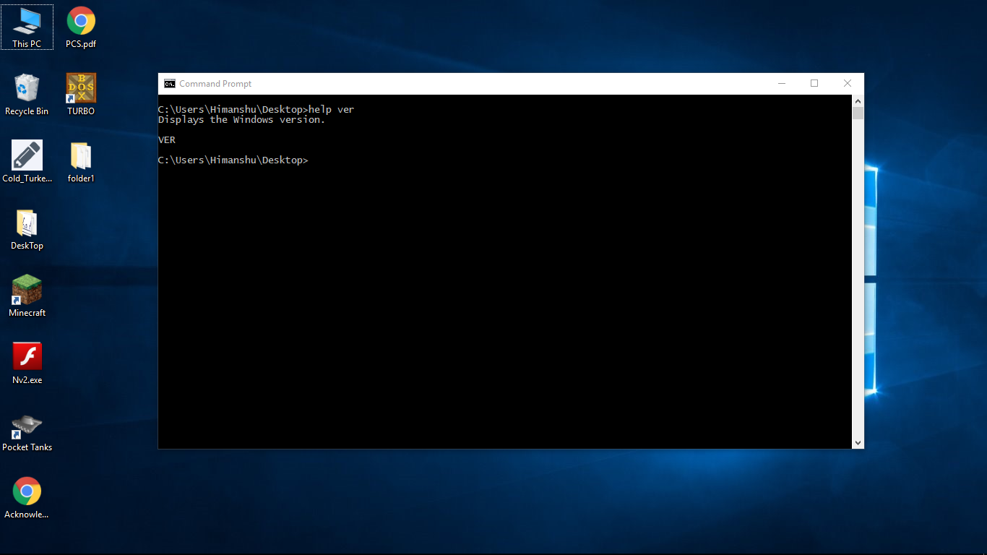

1. **MOVE**

Moves files or renames directories.

**Syntax:**

**C:\>MOVE [FILENAME] [NEWNAME]**

**C:\>MOVE[PATH|DIR_NAME] [NEWPATH]**

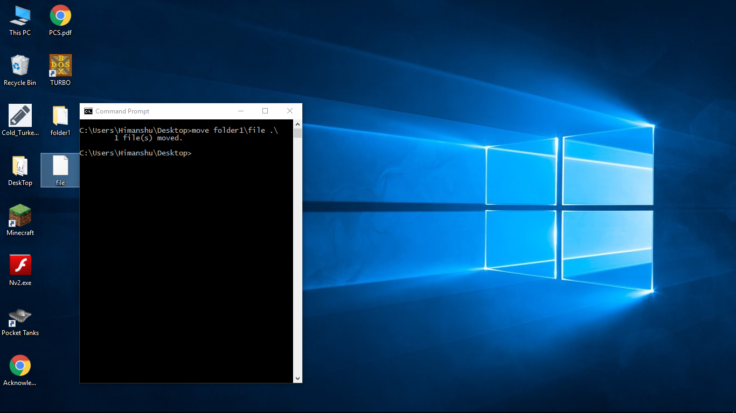

1. **XCOPY**

Copy entire directory trees. XCOPY is a powerful version of the copy command with additional features, has the capability of moving files, directories, and even whole drives from one location to another.

**Syntax:**

**C:\>XCOPY [PATH|DIR_NAME] [NEWPATH]**

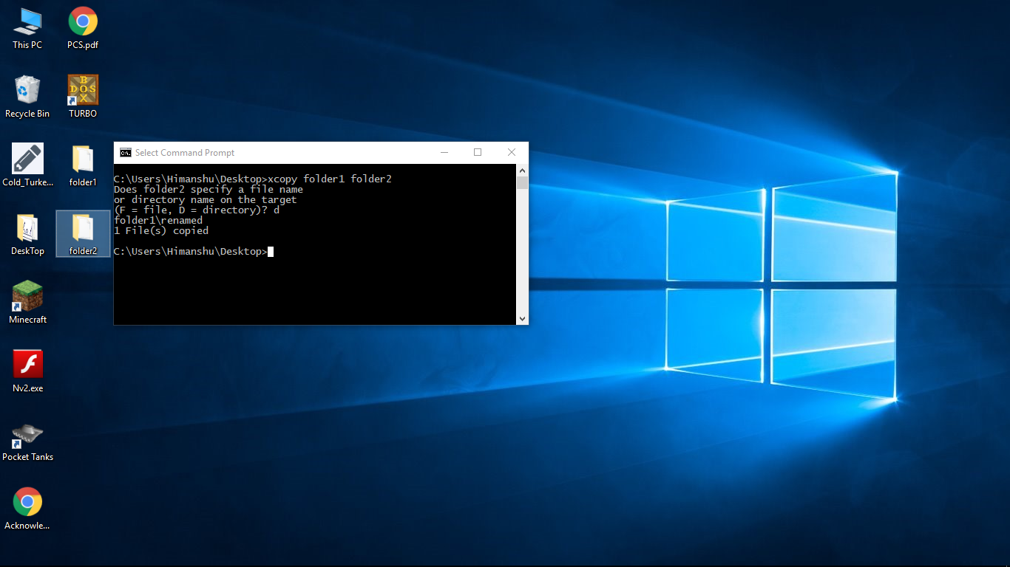

**MS-WORD**

Microsoft Word is a Word processing software Package. You can use it to type Letters, Reports & Other Documents. It gives you the ability to use your home computer as well as your Business Computer for Desktop Publishing.

**THE WORD INTERFACE**

When you open Word for the first time, the**Start Screen** will appear. From here, you'll be able to create a new document, choose a template, and access your recently edited documents. From the Start Screen, locate and select **Blank document** to access the Word interface.

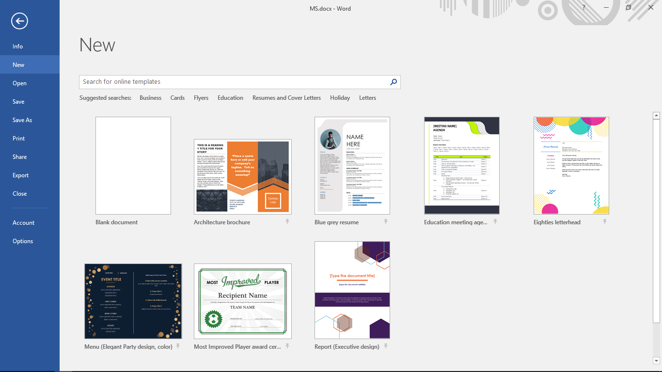

**Title Bar**

The Title bar displays the title of the document on which you are currently working. Word names the first new Document you open Document1. As you open additional new documents, Word names them sequentially. When you save your document, you assign the document a new name.

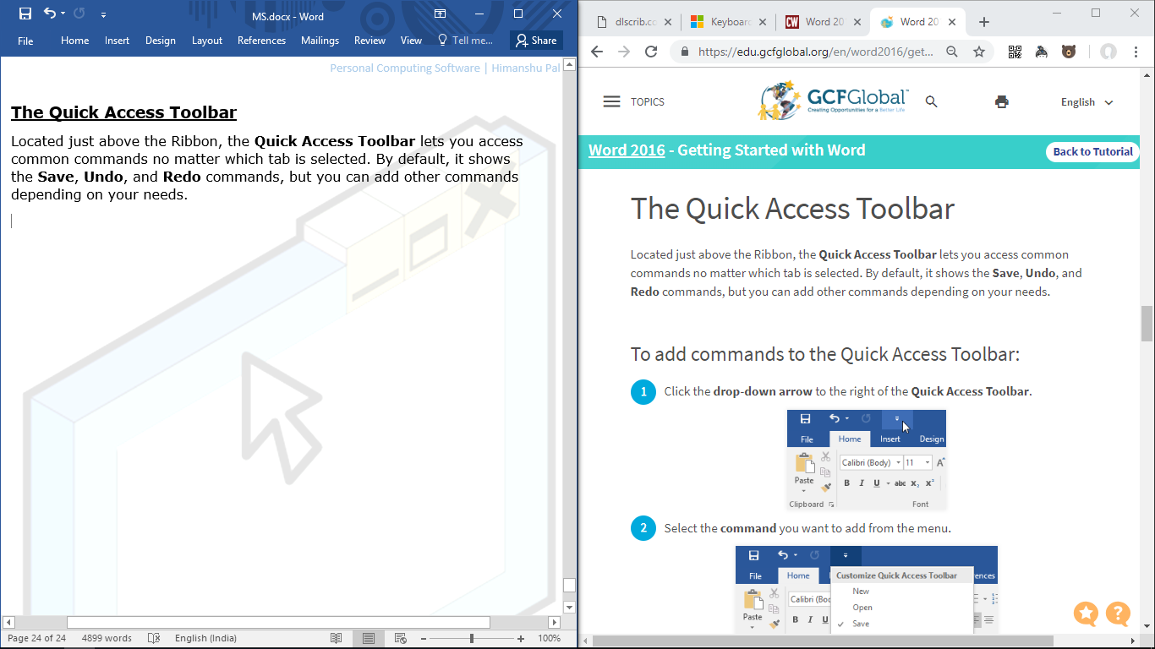

**The Ribbon**

Word uses a tabbed Ribbon system instead of traditional menus. The Ribbon contains Multiple tabs, which you can find near the top of the Word window.

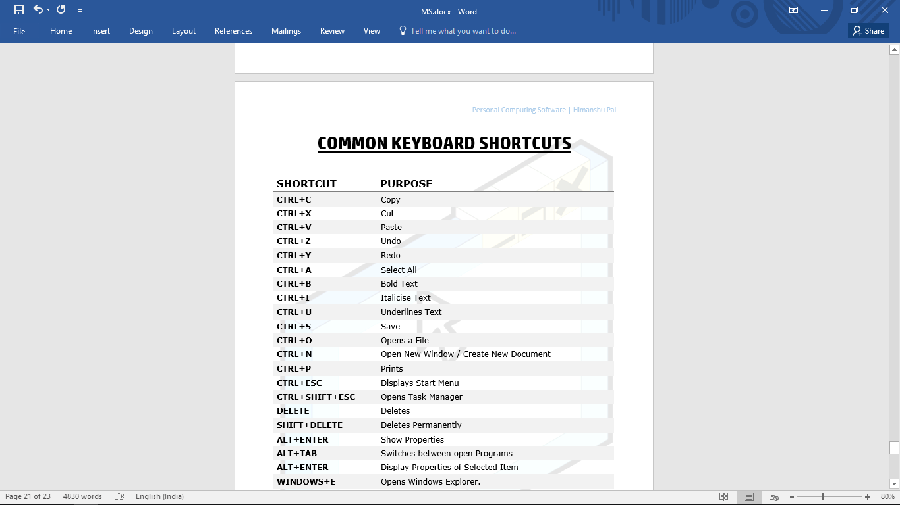

Each tab contains several **groups of related commands**. For example, the Font group on the Home tab contains commands for formatting text in your document.

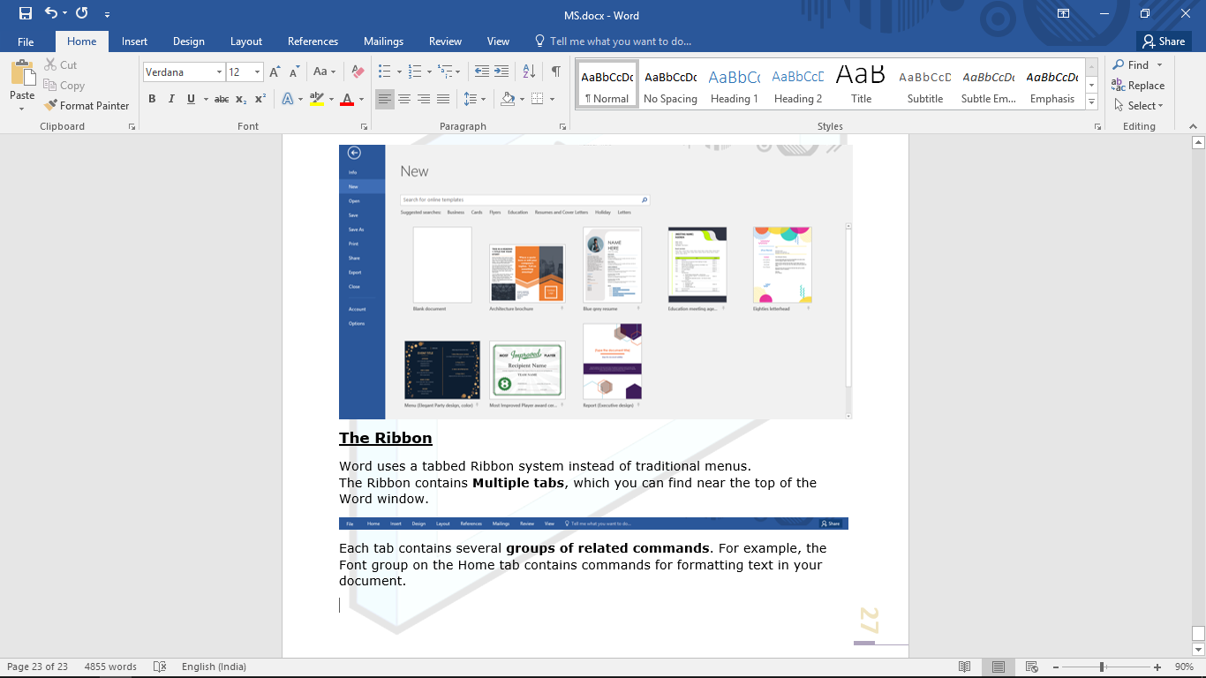

**The Quick Access Toolbar**

Located just above the Ribbon, the Quick Access Toolbar lets you access common commands no matter which tab is selected. By default, it shows the **Save**, **Undo**, and **Redo** commands, but you can add other commands depending on your needs.



**The Status Bar**

The Status bar appears at the very bottom of your window and provides such information as the current page and the number of words in your document.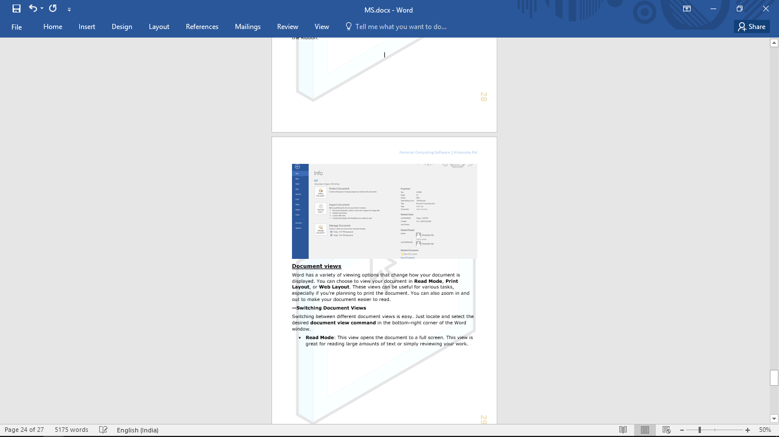

**The Text Area**

Just below the ruler is a large area called the text area. You type your document  in the text area. The blinking vertical line in the upper-left corner of the text area  is the cursor. It marks the insertion point. As you type, your text displays at the cursor location. The horizontal line next to the cursor marks the end of the document.

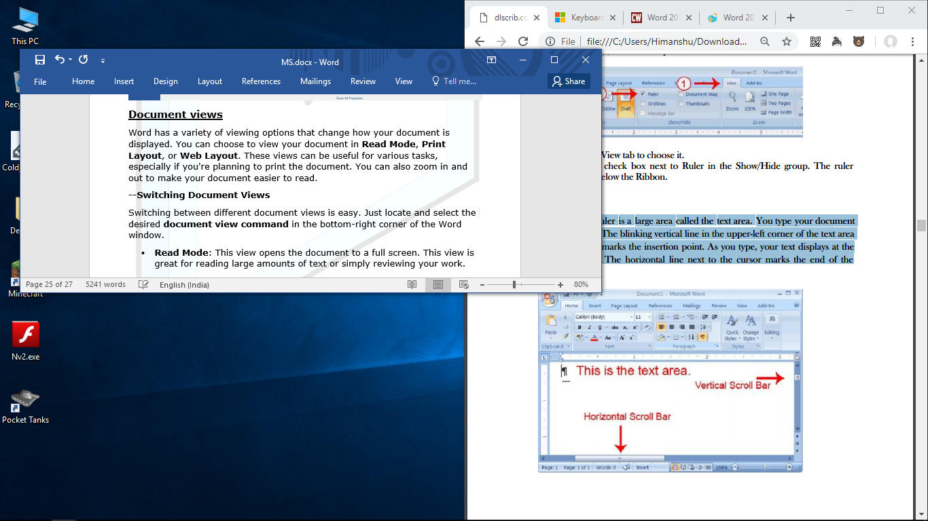

**Backstage view**

Backstage view gives you various options for saving, opening a file, printing, and sharing your document. To access Backstage view, click the File tab on the Ribbon.

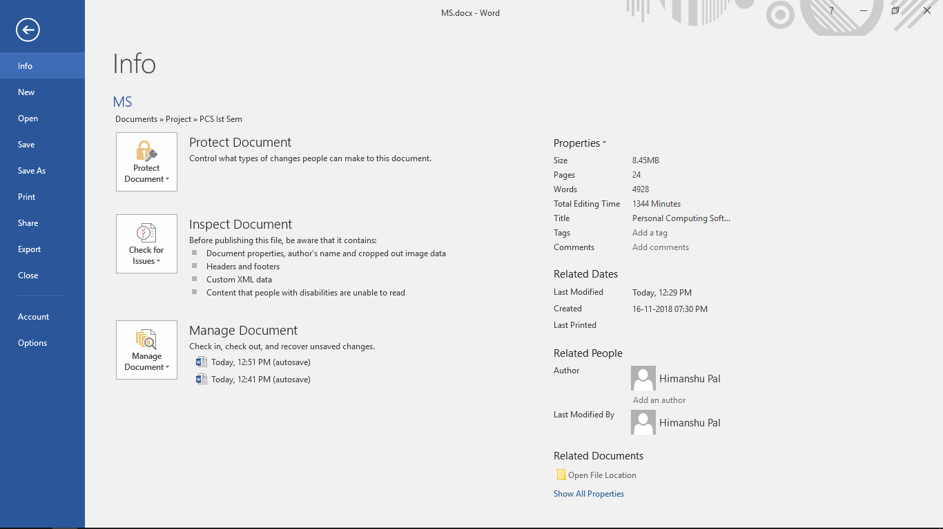

**Document views**

Word has a variety of viewing options that change how your document is displayed. You can choose to view your document in **Read Mode**, **Print Layout**, or **Web Layout**. These views can be useful for various tasks, especially if you're planning to print the document. You can also zoom in and out to make your document easier to read.



**--Switching Document Views**

Switching between different document views is easy. Just locate and select the desired **document view command** in the bottom-right corner of the Word window.

* **Read Mode**: This view opens the document to a full screen. This view is great for reading large amounts of text or simply reviewing your work.
* **Print Layout**: This is the default document view in Word. It shows what the document will look like on the printed page.
* **Web Layout**: This view displays the document as a webpage, which can be helpful if you're using Word to publish content online.

**CREATING / OPENING / SAVING DOCUMENTS**

When beginning a new project in Word, we need to start with a new blank document.

**To Create a New Blank Document**

1. Click the File tab to access Backstage view, then select New.
2. Click on **Blank document**.
3. A new blank document will appear.

A **Template** is a predesigned document you can use to create a new document quickly. Templates often include custom formatting and designs, so they can save you a lot of time and effort when starting a new project.

**To create a new document from a template**

1. Click the **File** tab to access Backstage view, then select **New**.
2. Several templates will appear below the Blank document option.
3. When you find something you like, select a template to preview it.
4. A **preview** of the template will appear. Click **Create** to use the selected template.
5. A new document will appear with the selected template.

In addition to creating new documents, you'll often need to open a document that was previously saved.

**To open an existing document**

1. Navigate to Backstage view, then click **Open**.
2. The Open dialog box will appear. Locate and **select** your document, then click **Open**.
3. The selected document will appear.

It's important to **save your document**whenever you start a new project or make changes to an existing one. Saving early and often can prevent your work from being lost. You'll also need to pay close attention to where you save the document so it will be easy to find later.

**To save a Document**

1. Locate and select the **Save** command on the **Quick** **Access Toolbar**.
2. If you're saving the file for the first time, the Save As pane will appear in backstage view.
3. You'll then need to choose where to save the file and give it a **File name**. Click **Browse** to select a location on your computer.
4. The **Save As** dialog box will appear. Select the location where you want to save the document.
5. Enter a file name for the document, then click Save.
6. The document will be saved. You can click the Save command again to save your changes as you modify the document.

**FORMATTING TEXT**

Formatted text can draw the **reader's attention** to specific parts of a document and emphasize important information. In Word, you have several options for adjusting text, including font, size, and color. You can also adjust the alignment of the text to change how it is displayed on the page.

**To Change the Font Size**

1. Select the text you want to modify.
2. On the Home tab, click the Font size drop-down arrow. Select a font size from the menu. If the font size you need is not available in the menu, you can click the Font size box and type the desired font size, then press Enter.
3. The font size will change in the document.



**To Change the Font Style**

1. Select the text you want to modify.
2. On the Home tab, click the drop-down arrow next to the Font box. A menu of font styles will appear.
3. Select the font style you want to use.
4. The font will change in the document.



**To Change the Font Color**

1. Select the text you want to modify.
2. On the Home tab, click the **Font Color** drop-down arrow. The Font Colormenu appears.
3. Select the font color you want to use. The font color will change in the document.



**To Bold, Italic, and Underline Text**

1. Select the text you want to modify.
2. On the Home tab, click the Bold (**B**), Italic (*I*), or Underline (U) command in the **Font** group. In our example, we'll click Bold.
3. The selected text will be modified in the document.



**To Change Text Case**

1. Select the text you want to modify.
2. On the Home tab, click the Change Case command in the Font group.
3. A drop-down menu will appear. Select the desired case option from the menu.
4. The text case will be changed in the document.



By **Default**, Word aligns text to the **Left Margin** in new documents. However, there may be times when you want to adjust text alignment to the center or right.

**To change Text Alignment**

1. Select the text you want to modify.
2. On the Home tab, select one of the Four Alignment options from the Paragraph group.
3. The text will be realigned in the document.



**To Highlight Text**

1. Select the text you want to highlight.
2. From the Home tab, click the Text Highlight Color drop-down arrow. The **Highlight Color** menu appears.
3. Select the desired highlightcolor. The selected text will then be highlighted in the document.



**To create a List**

1. Select the text you want to format as a list.
2. On the Home tab, click the drop-down arrow next to the Bullets command. A menu of bullet styles will appear.
3. Move the mouse over the various bullet styles. A live preview of the bullet style will appear in the document. Select the bullet style you want to use.
4. The text will be formatted as a bulleted list.



**PRINTING**

**To Print a Document**

1. Navigate to the **Print** pane, then select the desiredPrinter.
2. We’ll get Print **Preview** of the Document alongside Print Menu.
3. Enter the number of **copies** you want to print.
4. Select any additional settings if needed & click **Print**.

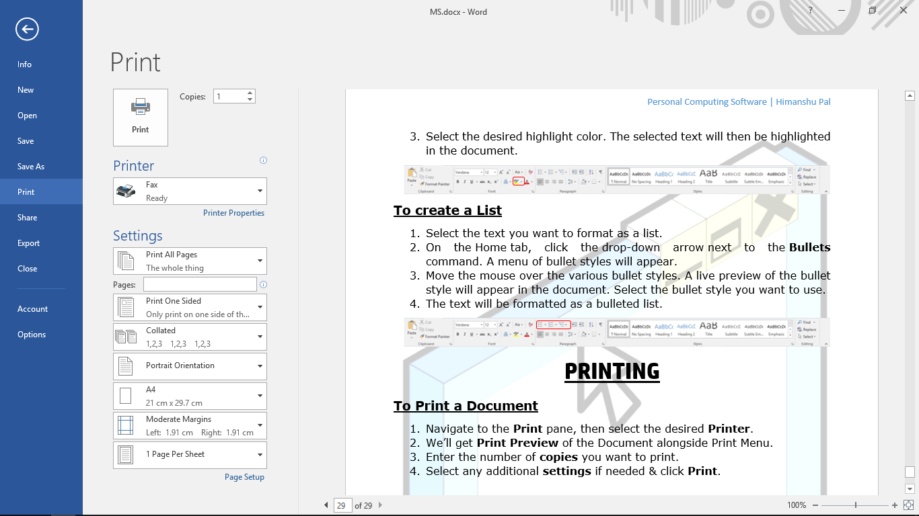

**WORD SHORTCUT KEYS**

|  |  |
| --- | --- |
| ****F1 Key**** | Get help on a selected command. |
| Shift + F1 | Review text formatting. |
| F2 Key | Move text or image. |
| Shift + F2 | Copy text. |
| Shift + F3 | Change the case of the selected text. |
| F4 Key | Perform last action again. |
| F5 Key | Displays the Go To dialogue box. |
| F7 Key | Launch the Spell Checker. |
| F8 Key | Extend the current selection. |
| Shift + F8 | Shrink the current selection. |
| F9 Key | Refresh. |
| Shift + F10 | Display a Shortcut Menu (same as right-clicking). |
| F12 Key | Open Save As. |
| Shift + F12 | Save document. |
| Ctrl + A | Selects all in the current document. |
| Ctrl + B | Bold text. |
| Ctrl + C | Copies the item or text. |
| Ctrl + D | Displays the Font dialogue box. |
| Ctrl + E | Switch a paragraph between Center and left alignment. |
| Ctrl + F | Displays the Find dialog box to search the current document. |
| Ctrl + H | Displays the Replace dialogue box. |
| Ctrl + I | Italicize text. |
| Ctrl + J | Switch a paragraph between justified and left alignment. |
| Ctrl + K | Create a hyperlink. |
| Ctrl + L | Left align a paragraph. |
| Ctrl + M | Indent a paragraph from the left. |
| Ctrl + N | Create a new document. |
| Ctrl + O | Opens a new document. |
| Ctrl + P | Prints a document. |
| Ctrl + R | Switch the alignment of a paragraph between left and right. |
| Ctrl + S | Saves a document. |
| Ctrl + U | Underlines text. |
| Ctrl + V | Pastes the copied item or text. |
| Ctrl + X | Cuts the selected item or text. |
| Ctrl + Y | Redo the last action. |
| Ctrl + Z | Undo the last action. |
| Ctrl + Enter | Insert a page break. |
| Ctrl + F2 | Select Print Preview command. |
| Ctrl + F4 | Closes the active window. |
| Ctrl + F6 | Opens the next window if multiple are open. |

**MS-EXCEL**

Microsoft Excel is an electronic spreadsheet. You can use it to organize  your data into rows and columns. You can also use it to perform mathematical calculations quickly.

**THE EXCEL INTERFACE**

When you open Excel 2016 for the first time, the **Excel Start Screen** will appear. From here, you'll be able to create a new workbook, choose a template, and access your recently edited workbooks. From the Excel Start Screen, locate and selectBlank workbookto access the Excel interface.

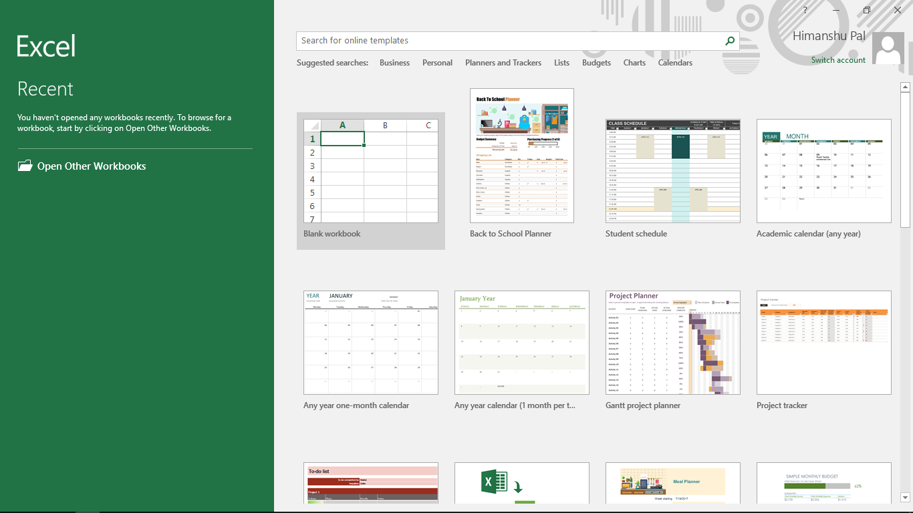

**Title Bar**

The Title bar displays the title of the Workbook on which you are currently working. Excel names the first new Workbook you open Book1. As you open additional new Workbooks, Excel names them sequentially. When you save your workbook, you assign the workbook a new name.

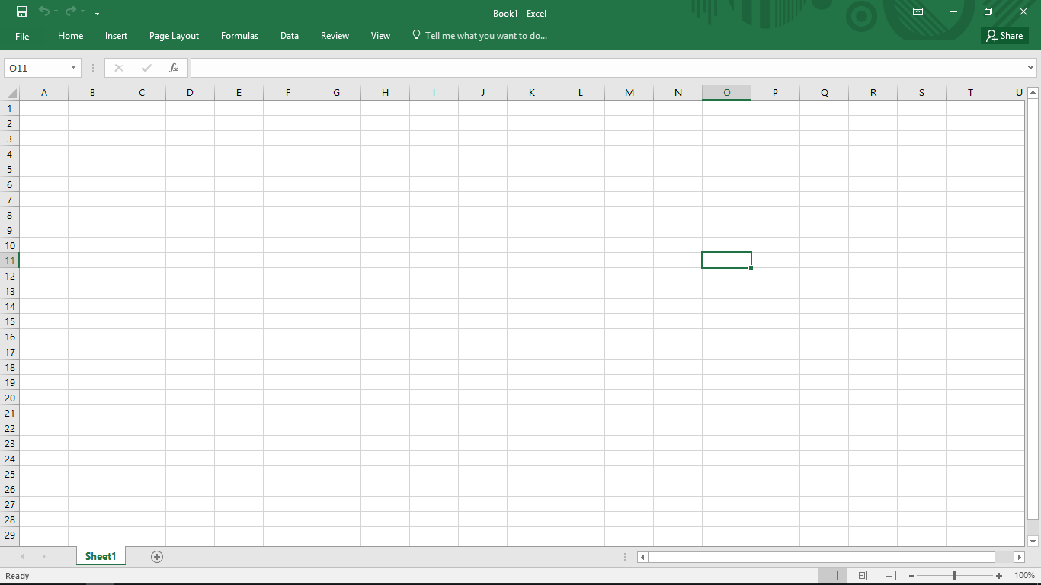

**The Ribbon**

Excel uses a tabbed Ribbon systeminstead of traditional menus. The Ribbon contains multiple tabs, each with several groups of commands. You will use these tabs to perform the most common tasks in Excel.

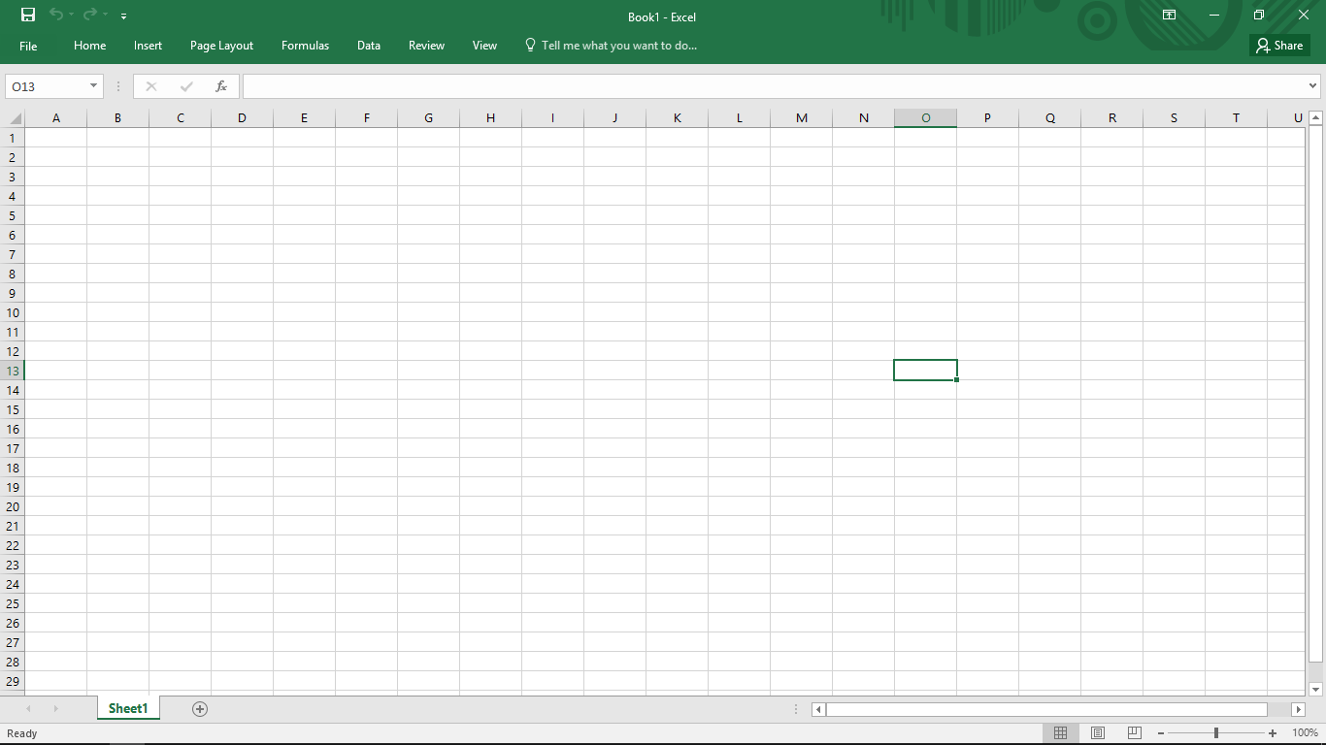 Each tab will have one or more groups. Click a tab to see more commands.

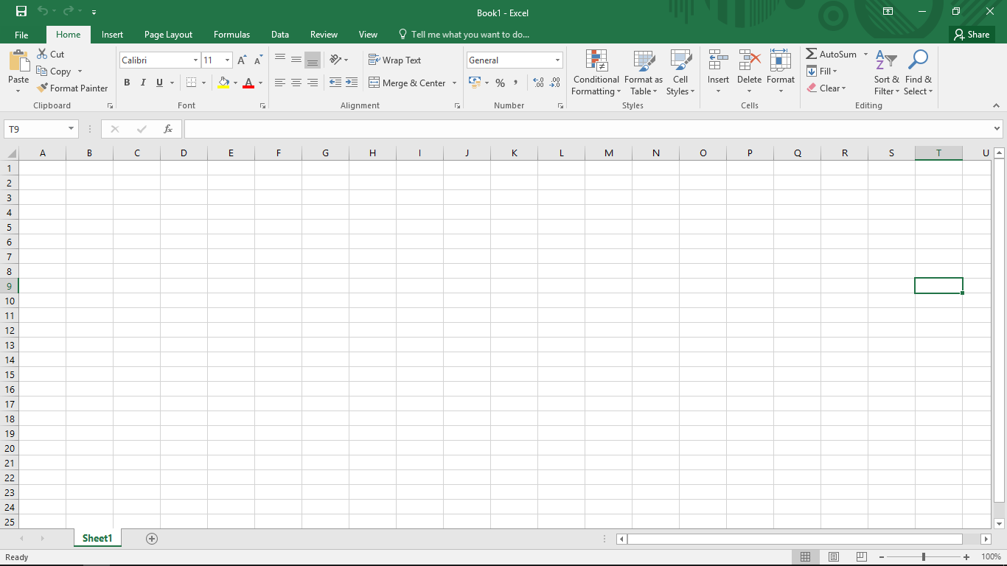

**The Quick Access Toolbar**

Located just above the Ribbon, the **Quick Access Toolbar** lets you access common commands no matter which tab is selected. By default, it includes the **Save**, **Undo**, and **Repeat** commands. You can add other commands depending on your preference.

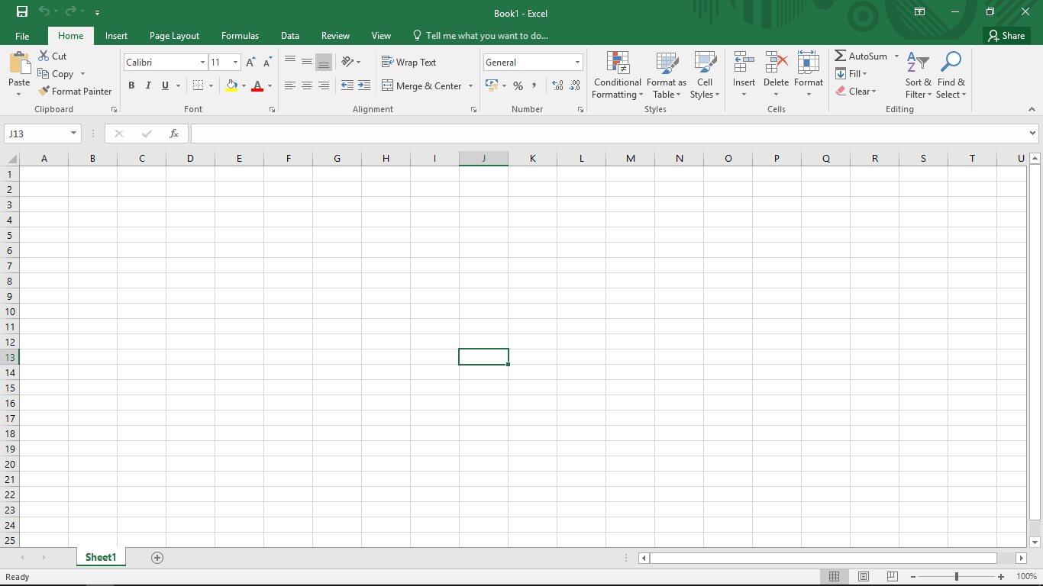

**Backstage view**

Backstage view gives you various options for saving, opening a file, printing, and sharing your Workbooks. To access Backstage view, click the File tab on the Ribbon.

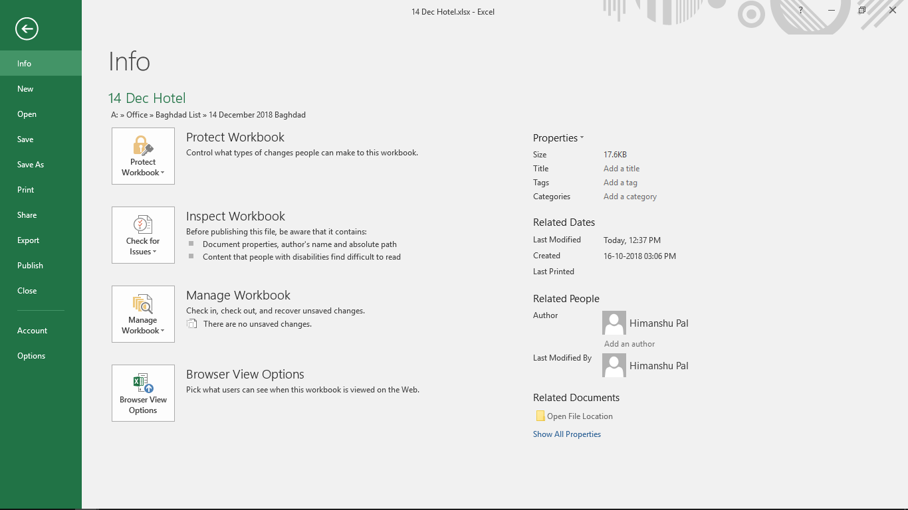

**Formula Bar**

A toolbar at the top of the Excel spreadsheet that you can use to enter or copy an existing formula in to cells or charts. It is labeled with function symbol (fx). By clicking the Formula Bar, or when you type an equal (=) symbol in a cell, the Formula Bar will activate.

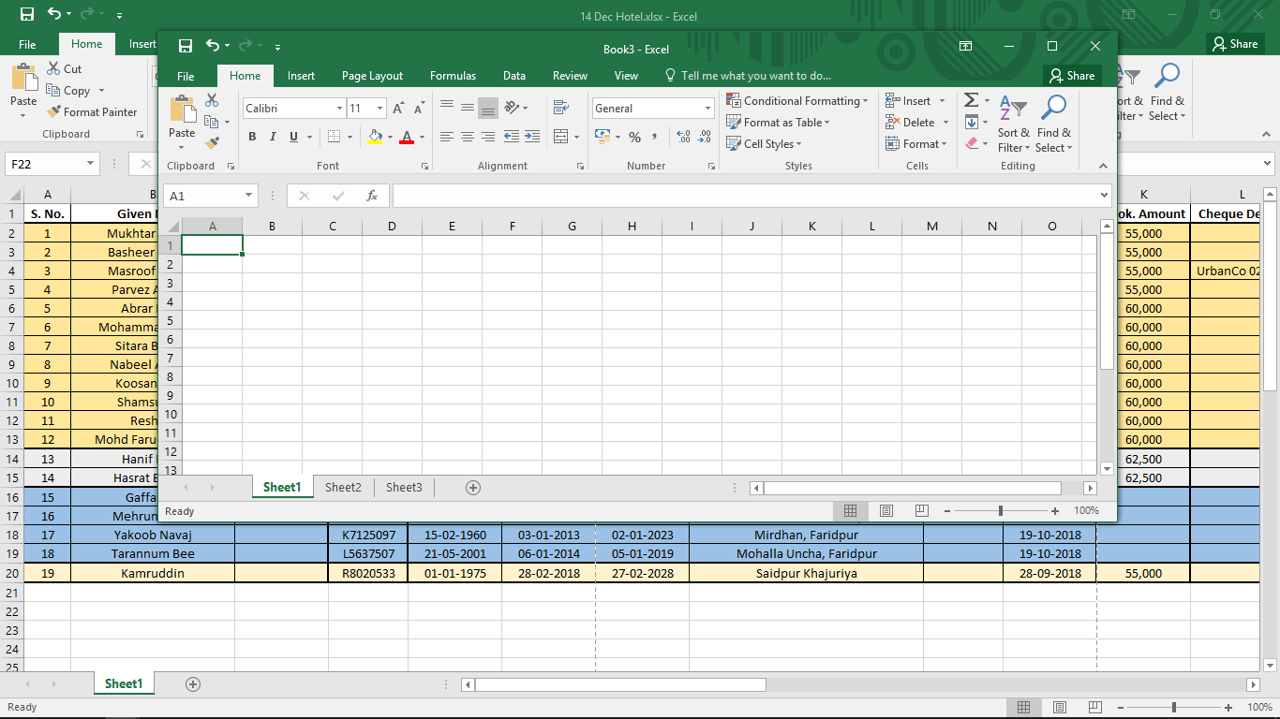

**Worksheet**

Excel consists of worksheets. Each worksheet contains columns and rows. The columns are lettered A to Z and then continuing with AA,  AB, AC and so on; the rows are numbered 1 to 1,048,576. The number of  columns and rows you can have in a worksheet is limited by your computer memory and your system resources. The combination of a column coordinate and a row coordinate make up a **Cell** **address**. For example, the cell located in the upper-left corner of the  worksheet is cell A1, meaning column A, row 1. Cell E10 is located under column E on row 10. You enter your data into the cells on the worksheet.



**Worksheet Views**

Excel 2016 has a variety of viewing options that change how your workbook is displayed. These views can be useful for various tasks, especially if you're planning to print the spreadsheet. To change worksheet views, locate the commands in the bottom-right corner of the Excel window and select **Normal view, Page Layout view,** or **Page Break view.**

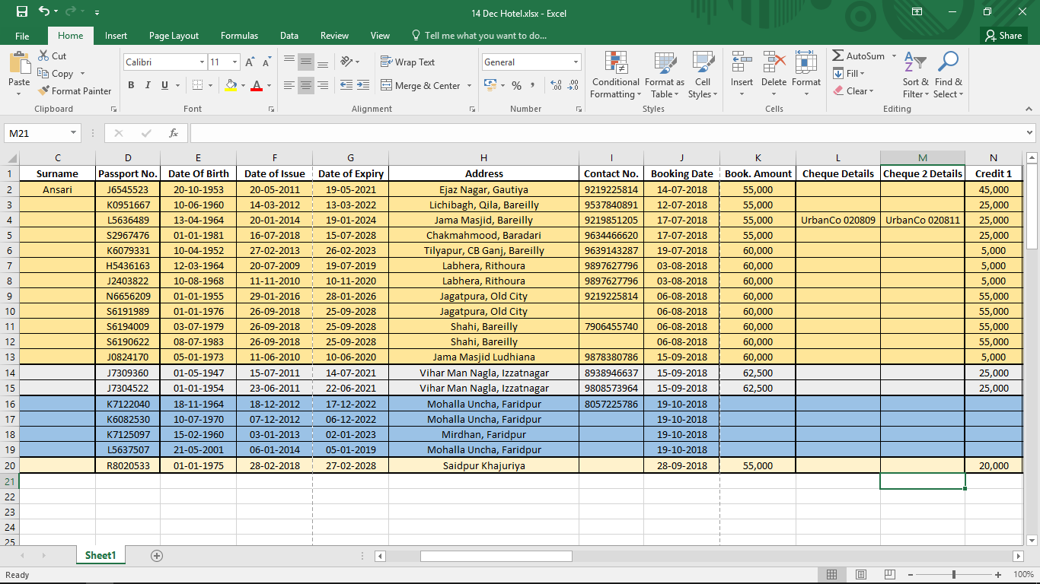

* **Normal view** is the Default View for all worksheets in Excel.
* **Page Layout view** displays how your worksheets will appear when printed. You can also add headers and footers in this view.
* **Page Break view** allows you to change the location of page breaks, which is especially helpful when printing a lot of data from Excel.

**CREATING / OPENING / SAVING WORKBOOKS**

Excel files are called workbooks. Whenever you start a new project in Excel, you'll need to create a new workbook.

**To Create a New Blank Workbook**

1. Click the File tab to access Backstage view, then select New.
2. Click on **Blank workbook.**
3. A new blank worksheet will appear.

A template is a predesigned spreadsheet you can use to create a new workbook quickly. Templates often include custom formatting and predefined formulas, so they can save you a lot of time and effort when starting a new project.

**To Create a Workbook using Template**

1. Click the File tab to access Backstage view.
2. Select New. Several templates will appear below the Blank workbook option.
3. Select a **Template** to review it.
4. A preview of the template will appear, along with additional informationon how the template can be used.
5. Click **Create**to use the selected template.
6. A new workbook will appear with the selected template.

In addition to creating new workbooks, you'll often need to open a workbook that was previously saved.

**To Open an existing workbook**

1. Navigate to Backstage view, then click Open.
2. Select **Computer**, then click **Browse**.
3. The **Open** dialog box will appear. Locate and select your workbook, then click Open.

It's important to **save your workbook**whenever you start a new project or make changes to an existing one. Saving early and often can prevent your work from being lost. You'll also need to pay close attention to **where you save** the workbook so it will be easy to find later.

**To Save a Workbook**

1. Locate and select the **Save** command on the **Quick** **Access Toolbar**.
2. If you're saving the file for the first time, the Save As pane will appear in Backstage view.
3. You'll then need to choose where to save the file and give it a file name. To save the workbook to your computer, select Computer, then click **Browse**.
4. The Save As dialog box will appear. Select the location where you want to save the workbook.
5. Enter a **File name** for the workbook, then click **Save**.
6. The workbook will be saved. You can click the Save command again to save your changes as you modify the workbook.

**CELLS**

**Understanding cells**

Every worksheet is made up of thousands of rectangles, which are called **cells**. A cell is the **intersection** of a **row** and a **column**—in other words, where a row and column meet.

Columns are identified by letters (A, B, C), while rows are identified by numbers (1, 2, 3).Each cell has its own name or cell address based on its column and row.

In the example below, the selected cell intersects **column C** and **row 5**, so the cell address is **C5**.

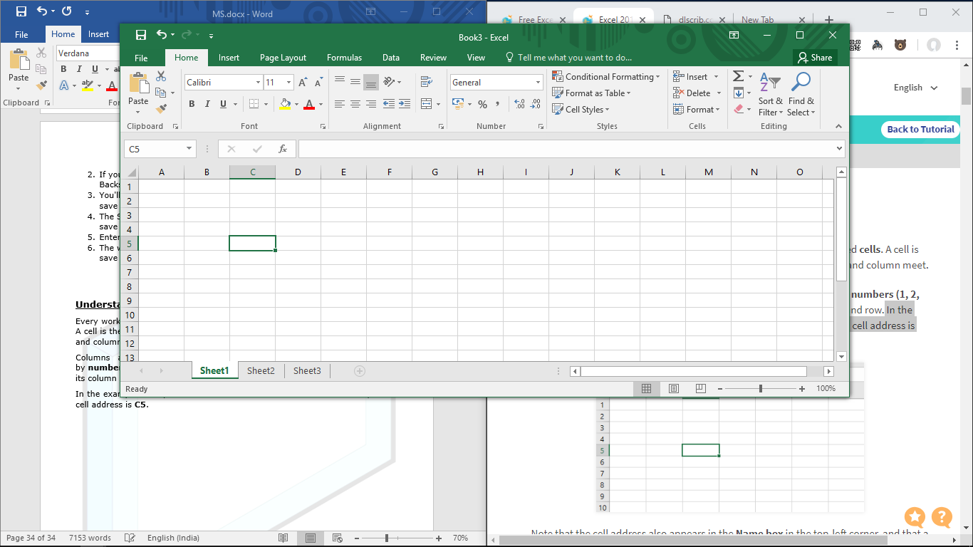

To input or edit cell content, you'll first need to **select** the cell.

**To select a cell**

1. Click a cellto select it. In our example, we'll select cell **D6**.
2. A**border** will appear around the selected cell, and the column heading and row heading will be highlighted. The cell will remain selected until you click another cell in the worksheet.

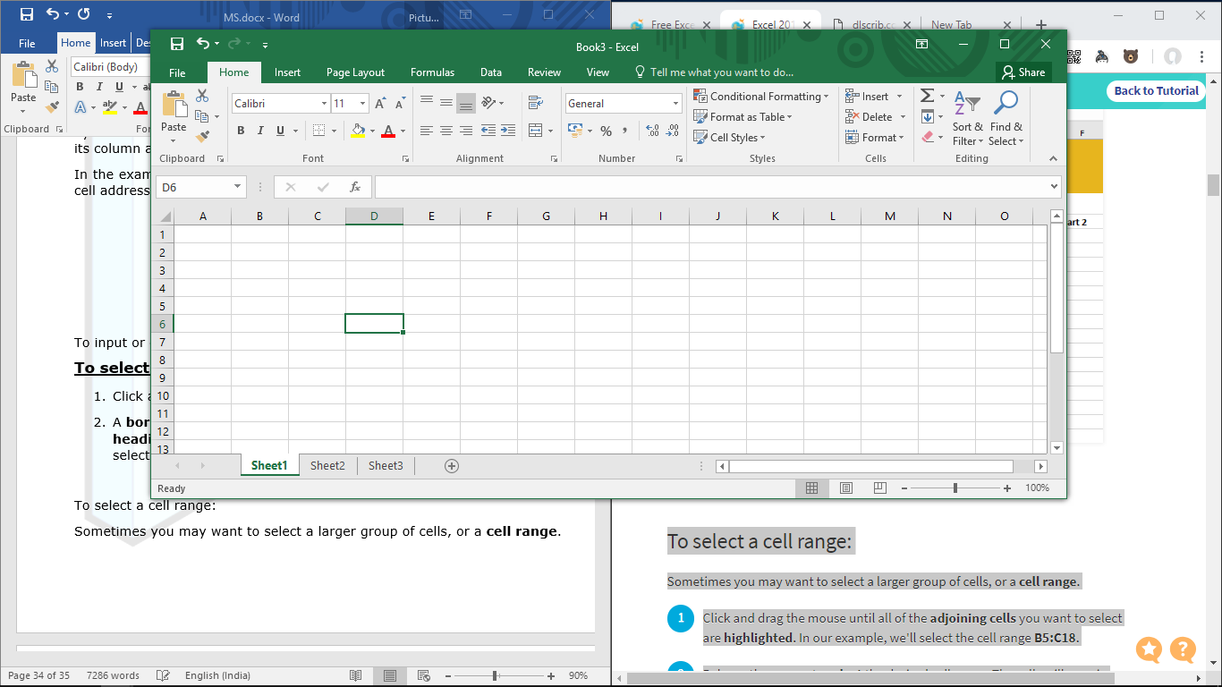

Sometimes you may want to select a larger group of cells, or a **cell range**.

**To select a cell range**

1. Click and drag the mouse until all of the adjoining cells you want to select are highlighted. In our example, we'll select the cell range **A5:D13**.
2. Release the mouse to select the desired cell range. The cells will remain selecteduntil you click another cell in the worksheet.

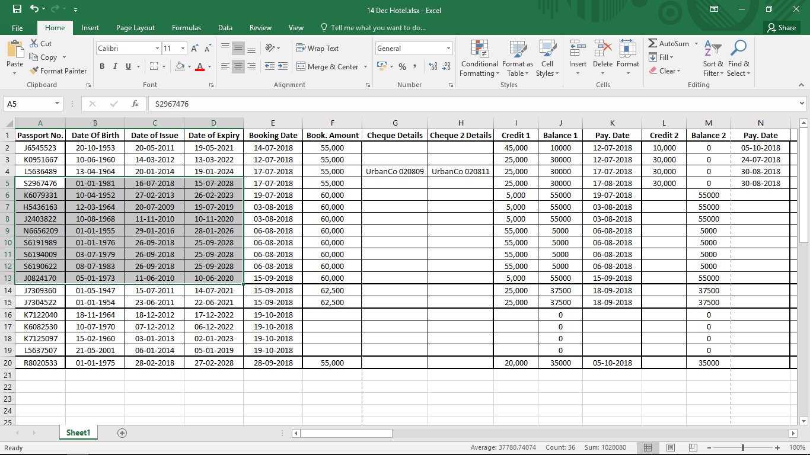

**Cell Content**

Any information you enter into a spreadsheet will be stored in a cell. Each cell can contain different types of content, including text, formatting, formulas, and functions.

* **Text:** Cells can contain text, such as letters, numbers, and dates.
* **Formatting attributes**:Cells can contain formatting attributes that change the way letters, numbers, and dates are displayed. For example, percentages can appear as 0.15 or 15%. You can even change a cell's text or background color.
* **Formulas and functions:** Cells can contain formulas and functions that calculate cell values.

**To Insert Content**

1. Click a cell to select it.
2. Type something into the selected cell, then press Enteron your keyboard. The content will appear in the cell and the formula bar. You can also input and edit cell content in the formula bar.

**To delete cell content**

1. Select the cell(s) with content you want to delete.
2. Select the **Clear** command on the Home tab, then click Clear Contents or press **Delete** keyon keyboard.
3. The cell contents will be deleted.

**MODIFYING COLUMNS / ROWS / CELLS**

By default, every row and column of a new workbook is set to the same **height**and **width**. Excel allows you to modify column width and row height in different ways, including wrapping text andmerging cells.

**To modify column width**

1. Position the mouse over the column line in the column heading so the cursor becomes a double arrow.
2. Click and drag the mouse to **increase** or **decrease** the column width.
3. Release the mouse. The column width will be changed.

The **AutoFit** feature will allow you to set a column's width to fit its content automatically.

**To Autofit column width**

1. Position the mouse over the column line in the column headingso the cursor becomes a double arrow.
2. Double-click the mouse. The column width will be changed automatically to fit the content.

**To modify row height**

1. Position the cursor over the row lineso the cursor becomes a double arrow.
2. Click and drag the mouse to **increase** or **decrease** the row Height.
3. Release the mouse. The height of the selected row will be changed.

Instead of resizing rows and columns individually, you can modify the height and width of every row and column at the same time. This method allows you to set a **uniform size** for every row and column in your worksheet.

**To modify all Rows and Columns**

1. Locate and click the **Select All**button just below thename box to select every cell in the worksheet.
2. Position the mouse over a row line so the cursor becomes a double arrow.
3. Click and drag the mouse to **increase** or **decrease** the row height, then release the mouse when you are satisfied. The row height will be changed for the entire worksheet.

**FORMULAS IN EXCEL**

One of the most powerful features in Excel is the ability to **calculate**numerical information using **formulas**. Just like a calculator, Excel can add, subtract, multiply, and divide.

**To create a formula**

1. Select the cell that will contain the formula. In our example, we'll select cell **C10**.
2. Type the **equals sign (=)**. Notice how it appears in both the **cell** and the **formula** **bar**.
3. 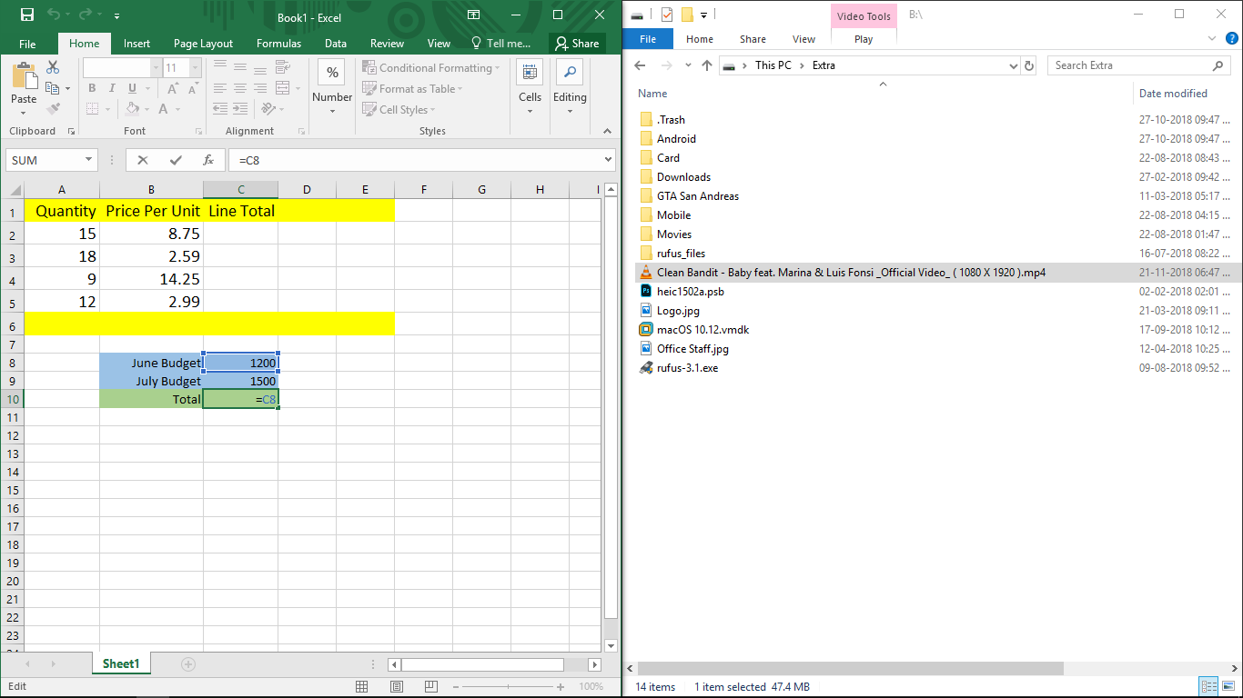Type the cell address of the cell you want to reference first in the formula: cell **C8** in our example. A **blue border** will appear around the referenced cell.

1. Type the mathematical operator you want to use. In our example, we'll type the **addition sign**(**+**).
2. 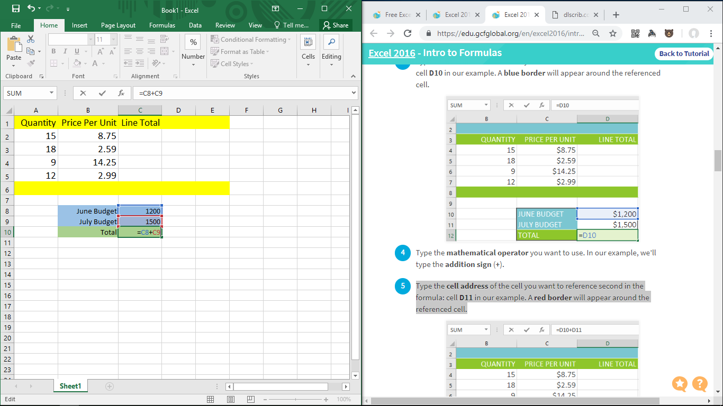Type the cell address of the cell you want to reference second in the formula: cell **C9** in our example. A **red border** will appear around the referenced cell.
3. 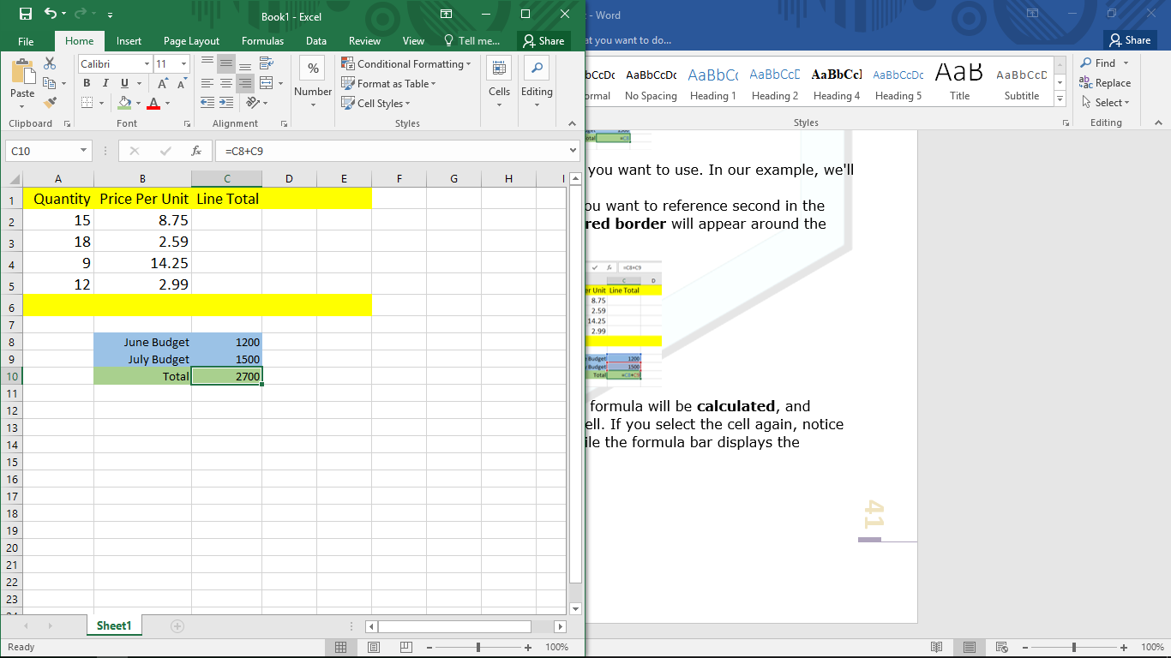Press **Enter**on your keyboard. The formula will be **calculated**, and the value will be displayed in the cell. If you select the cell again, notice that the cell displays the result, while the formula bar displays the formula.

**WORKING WITH MULTIPLE WORKSHEETS**

Every workbook contains at least one worksheet by default. When working with a large amount of data, you can create multiple worksheets to help organize your workbook and make it easier to find content. You can also groupworksheets to quickly add information to multiple worksheets at the same time.

**To insert a new worksheet**

1. Locate and select the new sheet button near the bottom-right corner of the Excel window.
2. A new blank worksheet will appear.

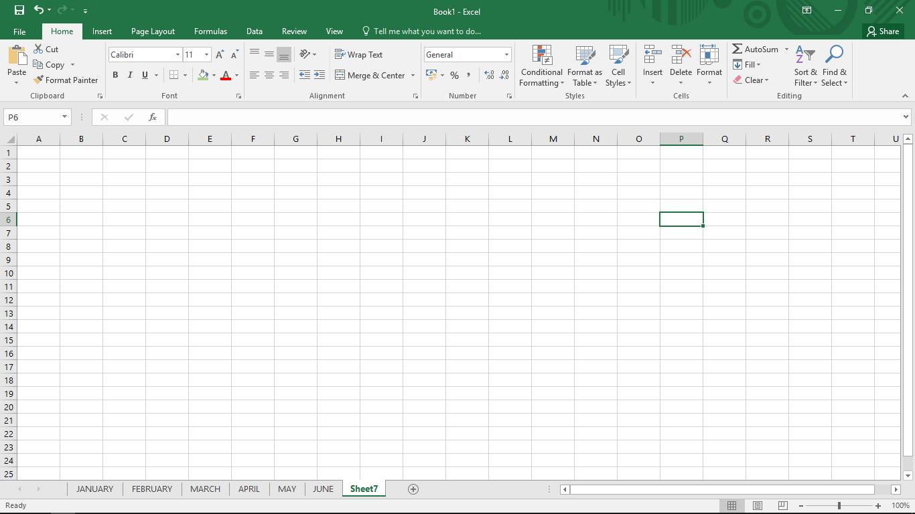

**Deleting Worksheet**

1. Right-click the worksheet you want to delete, then select **Delete** from the worksheet menu.
2. The worksheet will be deleted from your workbook.

**To change the worksheet tab color**

1. Right-click the desired worksheet tab, and hover the mouse over Tab Color. The **Color** menu will appear.
2. Select the desired color.

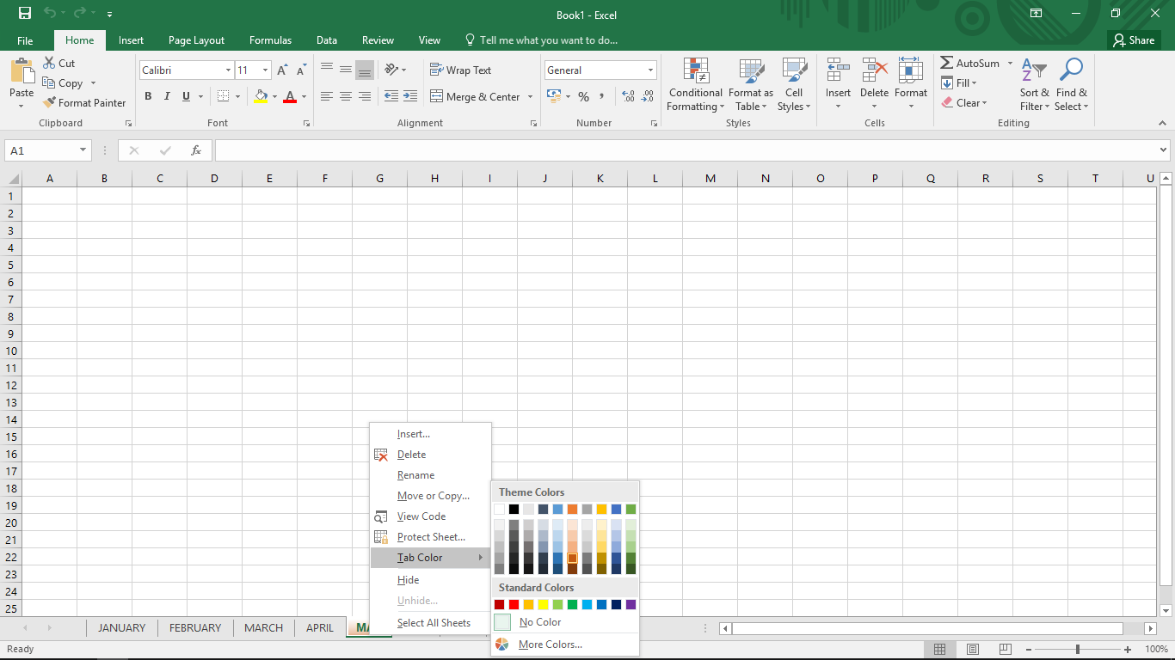

1. The worksheet tab color will be changed.

**CHARTS IN EXCEL**

It can be difficult to interpret Excel workbooks that contain a lot of data. **Charts** allow you to illustrate your workbook data **graphically**, which makes it easy to visualize **comparisons** and **trends**. Excel has several different types of charts, allowing you to choose the one that best fits your data.

**To insert a chart**

1. Select the cells you want to chart, including the column titles and row labels. These cells will be the source data for the chart. In our example, we'll select cells A1:F6.

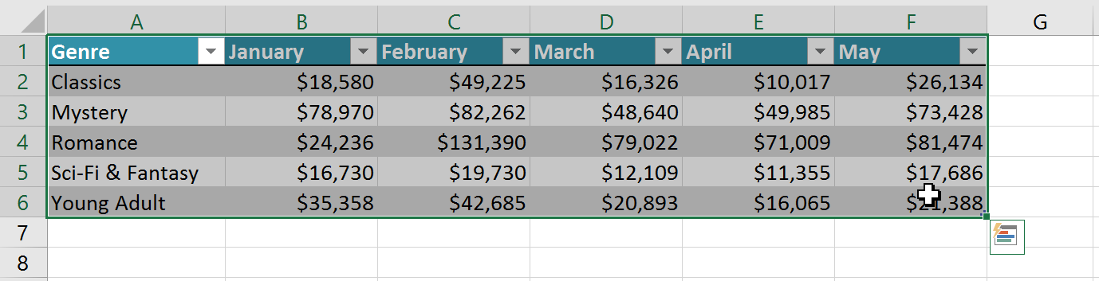

1. From the **Insert** tab, click the desired Chart command. In our example, we'll select Column.

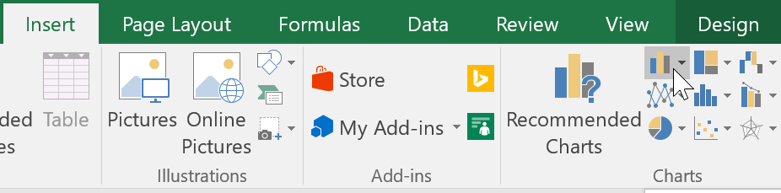

1. Choose the desired **chart type** from the drop-down menu.

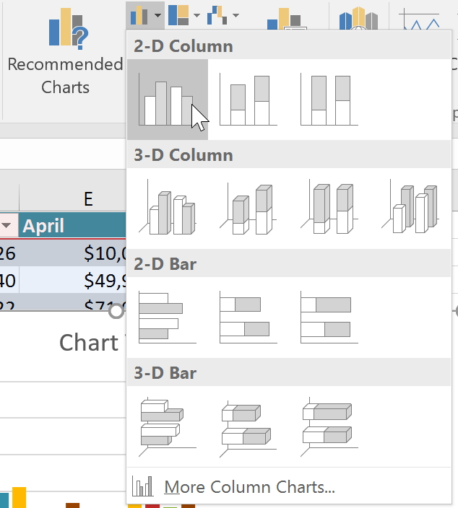

1. The Selected chart will be inserted into the worksheet.

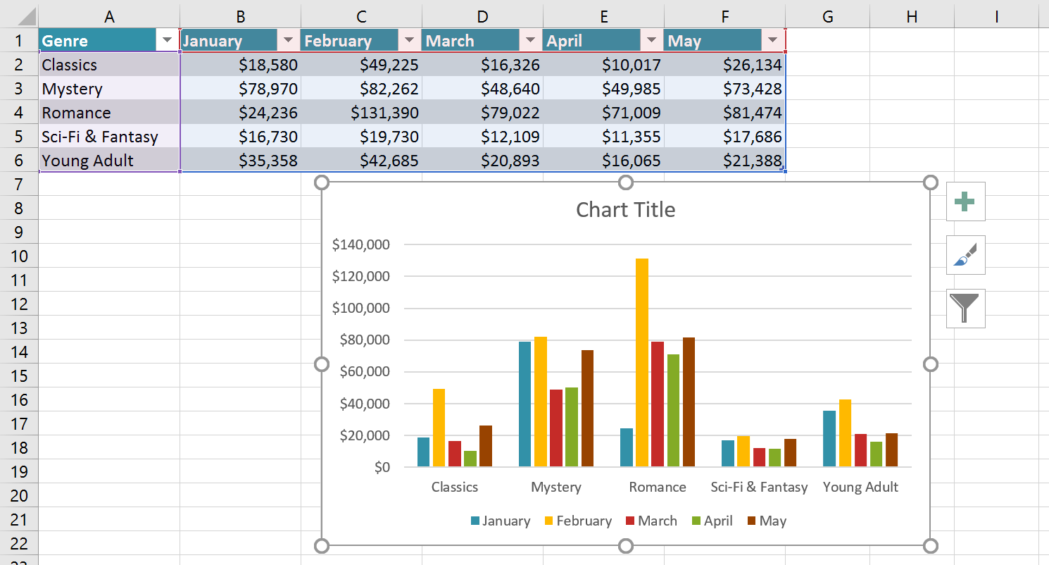

**Changing Chart Type**

1. From the **Design** tab, click the Change Chart Type command.
2. The Change Chart Type dialog box will appear. Select a **new chart type** and layout, then click **OK**.
3. The selected chart type will appear.

**Switching Row / Column Data**

1. Select the chart you want to modify.
2. From the **Design** tab, select the Switch Row/Column command.
3. The rows and columns will be **switched**.

Whenever you insert a new chart, it will appear as an object on the same worksheet that contains its source data. Alternatively, you can move the chart to a new worksheet to help keep your data organized.

**Moving a Chart**

1. Select the chart you want to move.
2. Click the **Design** tab, then select the Move Chart command.
3. The **Move Chart** dialog box will appear. Select the desired location for the chart.
4. Click OK.

**FORMATTING CELLS**

All cell content uses the same formatting by default, which can make it difficult to read a workbook with a lot of information. Basic formatting can customize the look and feelof your workbook, allowing you to draw attention to specific sections and making your content easier to view and understand.

**To Change the Font Size**

1. Select the cell(s) you want to modify.
2. On the Home tab, click the drop-down arrow next to the Font Sizecommand, then select the desired font size.
3. The text size will change to the selected font size.

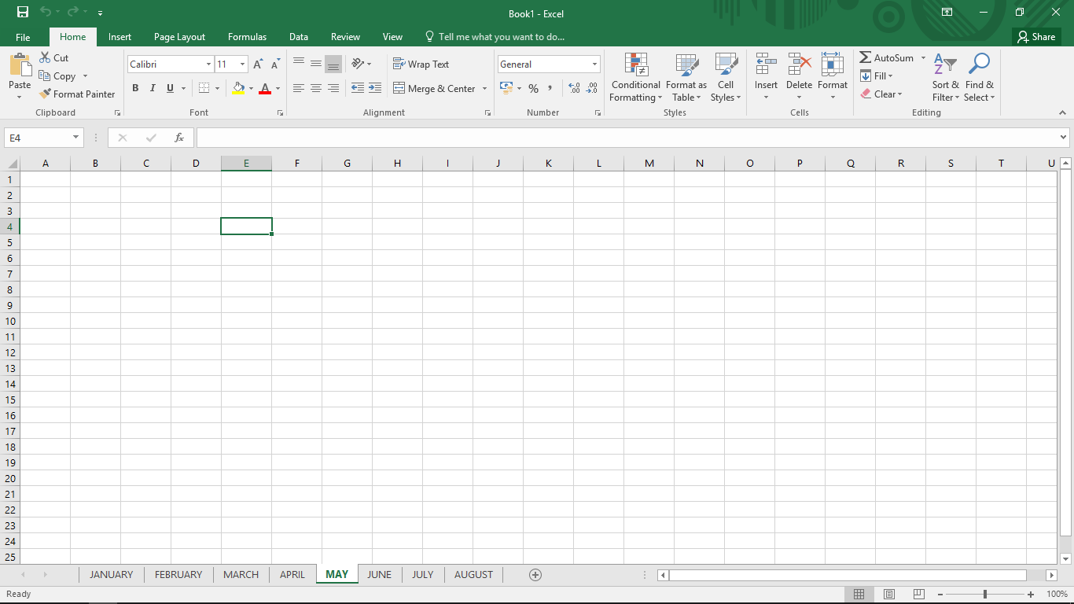

**To Change the Font**

1. Select the cell(s) you want to modify.
2. On the Home tab, click the drop-down arrow next to the Font command, then select the desired font.
3. The text will change to the selected font.



**To Change the Font Color**

1. Select the cell(s) you want to modify.
2. On the Home tab, click the drop-down arrow next to the Font Colorcommand, then select the desired font color.
3. The text color will change to the selected font color.



**To Bold, Italic, and Underline Text**

1. Select the cell(s) you want to modify.
2. On the Home tab, click the Bold (**B**), Italic (*I*), or Underline (U) command in the **Font** group.
3. The selected style will be applied to the text.



**To Change Horizontal Text Alignment**

1. Select the cell(s) you want to modify.
2. Select one of the three horizontal alignment commands on the Home tab.
3. The text will realign.



**To change vertical text alignment**

1. Select the cell(s) you want to modify.
2. Select one of the three vertical alignment commands on the Home tab.
3. The text will realign.



**CELL BORDER AND FILL COLOR**

**Cell borders** and**Fill colors** allow you to create clear and defined boundaries for different sections of your worksheet.

**To add a fill color**

1. Select the cell(s) you want to modify.
2. On the **Home** tab, click the drop-down arrow next to the **Fill Color** command, then select thefill color you want to use.
3. The selected fill color will appear in the selected cells.



**To add a Border**

1. Select the cell(s) you want to modify.
2. On the **Home** tab, click the drop-down arrow next to the **Borders** command, then select the border style you want to use.
3. The selected border stylewill appear.



**PRINTING**

There may be times when you want to print a workbook to view and share your data offline. Once you've chosen your page layout settings, it's easy to preview and print a workbook from Excel using the Print pane.

1. Select the File tab. Backstage view will appear.
2. Navigate to the Print pane, then select the desired**printer**.
3. Enter the number of **copies** you want to print.
4. Select any additional settings if needed.
5. A preview of your selection will appear in the **Preview**pane.
6. Click Print.

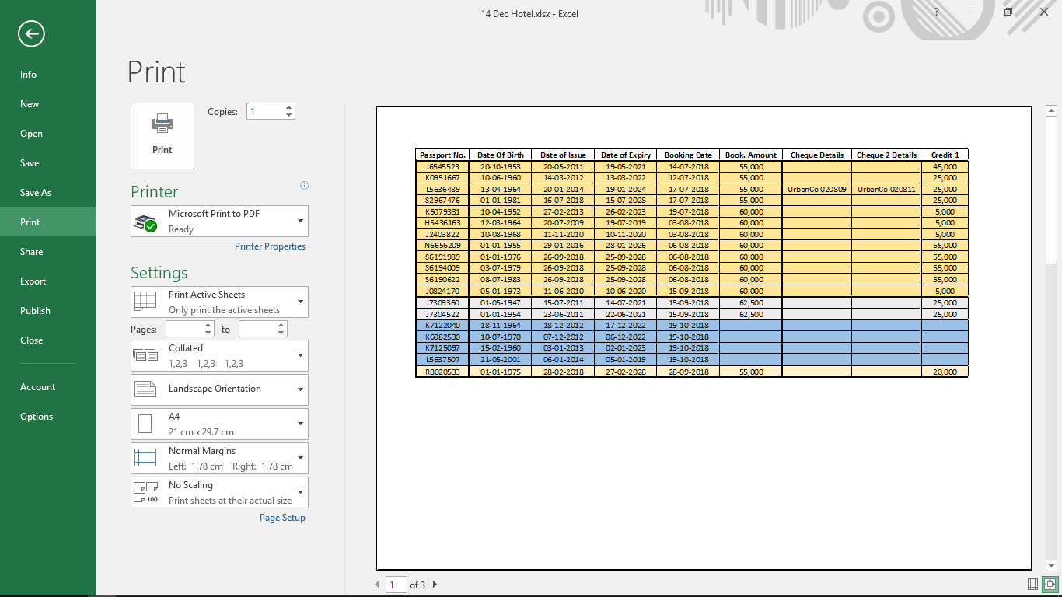

**To print a Selection**

1. Select the cells you want to print.
2. Navigate to the Print pane.
3. Select Print Selection from the Print Range drop-down menu.
4. A preview of your selection will appear in the **Preview**pane.
5. 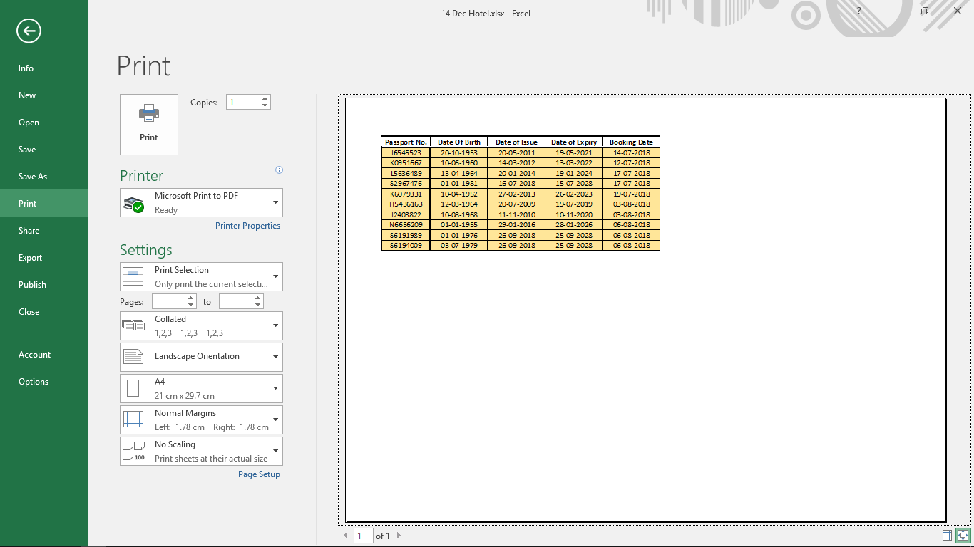Click the **Print** button to print the selection.

**EXCEL SHORTCUT KEYS**

|  |  |
| --- | --- |
| F2 | Edit the active cell. |
| F5 | Displays the Go To box. |
| F7 | Open the Spelling dialogue box to check a selected range. |
| F11 | Create a chart of data in the current range in a separate sheet. |
| Alt + Shift + F1 | Insert a new worksheet. |
| Shift + F3 | Opens Insert Function dialogue box. |
| Shift + F5 | Opens the Find and Replace dialogue box. |
| Ctrl + Shift + : | Enter the current time. |
| Ctrl + ; | Enter the current date. |
| Ctrl + A | Select all content in the worksheet. |
| Ctrl + B | Bold highlighted selection. |
| Ctrl + I | Italicize highlighted selection. |
| Ctrl + K | Open the Insert hyperlink dialogue box. |
| Ctrl + U | Underline highlighted selection. |
| Ctrl + 5 | Apply strikethrough formatting. |
| Ctrl + P | Brings up the print dialog box. |
| Ctrl + Z | Undo. |
| Ctrl + F9 | Minimize a workbook window to an icon. |
| Ctrl + F10 | Maximize a selected workbook window. |
| Ctrl + F6 | Switch to the next workbook window when multiple are open. |
| Ctrl + Page Up | Move to previous sheet in a workbook. |
| Ctrl + Page Down | Move to next sheet in a workbook. |
| Ctrl + Tab | Switch to next tab in dialogue box. |
| Ctrl + ' | Insert the value of the above cell into the cell currently selected. |
| Ctrl + Shift + ! | Apply the Number format. |
| Ctrl + Shift + $ | Apply the Currency format. |
| Ctrl + Shift + # | Apply the Date format. |
| Ctrl + Shift + % | Apply the Percentage format. |
| Ctrl + Shift + ^ | Apply the Exponential format. |
| Ctrl + Shift + @ | Apply the Time format. |
| Ctrl + Arrow Key | Move to the edge of the current data region in a worksheet. |
| Ctrl + Space | Select an entire column in a worksheet. |
| Shift + Space | Select an entire row in a worksheet. |